Furkat Ganiev
MD, PhD
Director of the Centre of Forensic Medicine of Sughd region
Tel: (+992) 98 529 00 55
Email: furkat.ganiev@gmail.com

After completing a master’s program in 2003, Furkat Ganiev joined the Department of Forensic Medicine of the Tajik State University as an assistant, where he worked until 2010. In 2011, he became the Head of the Department of Postgraduate Medical Training. In 2006, he completed a PhD program with a thesis topic “Forensic and Medico-Social Problems Relating to Suicides in the Republic of Tajikistan”. Since 2005, he has been a professor of Criminalistics and Forensic Expertise at the Department of Forensic Medicine, Law Faculty of the Tajik State University. In 2011, Furkat was appointed Deputy Director of the Republican Center of Forensic Medicine under the Ministry of Health of the Republic of Tajikistan (MoH). September 10, 2015 Ganiev was appointed Director of the Centre of Forensic Medicine of Sughd region as advised by MoH.
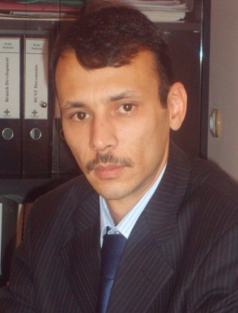
Since 2013, he is a member of the MoH Working Group on the implementation of the Istanbul Protocol. Editor of the Collection of Forensic Laws and Regulations, and the Methodology of Forensic Medical Examination approved by MoH and Ministry of Social Protection in 2014.
In 2015-2016, in partnership with the Human Rights Center Public Association he conducted a series of trainings for health professionals, members of the group to monitor places of detention, and judges on documenting cases of torture and other ill-treatment in accordance with the Istanbul Protocol.

