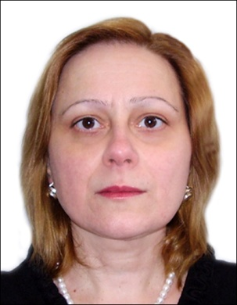
Mariam Jishkariani, MD
Dr. Mariam Jishkariani is Certified Doctor Psychiatrist since 1990. She is founder president and director of the RCT/EMPATHY; member of the Board of Directors of the Georgian Medical Association (GMA) and Head of the Section on Torture at the Society of Georgian Psychiatrists; Guest teacher at the Tbilisi Sate Medical University, Division of Psychiatry; Mental Health Advisory Board Member of the Ministry of Labor, Health and Social Welfare of Georgia and Georgian Parliament Health Committee. Member and former executive council member of the World Psychiatric Association (WPA) scientific section “Torture Psychological Consequences and Persecution”, member of the Penal Reform International (PRI); PHR expert. Since 1997 she has teaching experience. During 24 years of professional experience she participated as expert/trainer in more than 20 international, regional or national training/seminars related to torture, health in prison and stress related disorders, organized for doctors “at risk” and legal experts. She participated and made presentations in more than 30 national and international meetings and conferences published more than 40 articles, papers, books, reports on Georgian, Russian and English languages.

