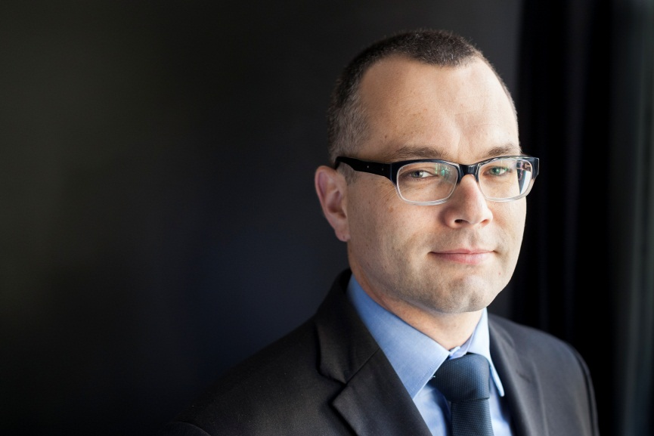

Mikołaj Pietrzak – advocate, member of the Polish Bar Association, member of the Board of Trustees of the UN Voluntary Fund for Victims of Torture
Mikołaj Pietrzak is a graduate of the University of Warsaw Faculty of Law and Administration and a holder of the Cambridge University Certificate in English and European Law. Mikołaj Pietrzak is a partner in Pietrzak Sidor & Partners Law Firm.

Mikołaj Pietrzak is a member of the Warsaw Bar Association, Chairman of the Human Rights Commission of the Polish Bar Council. He was the 2013 recipient of the Edward Wende award, which recognizes lawyers who dedicate themselves to the fight for justice and defence of the public good.

Mikołaj Pietrzak is a member of a number of international organizations for lawyers including the European Criminal Bar Association, the National Association of Criminal Defence Lawyers in the United States of America and the Legal Experts Advisory Panel for Fair Trials International. Since 2014, he is a member of the Doughty Street Chambers with the registered office in London. He is a permanent representative of the Polish Bar at the Council of Bars and Law Societies of Europe (CCBE) in the Human Rights Commission and the CCBE Permanent Deputation at the European Court of Human Rights in Strasbourg. In 2016, he was appointed to the Board of Trustees of the UN Voluntary Fund for Victims of Torture.
He specializes in criminal law and protection of human rights.

