Sana Hamzeh Psychotherapist, Psychology Doctorate in Grief Counseling
Clinical Director for Treatment and Rehabilitation of Torture and Trauma survivors
Restart Center for Rehabilitation of victims of violence and torture
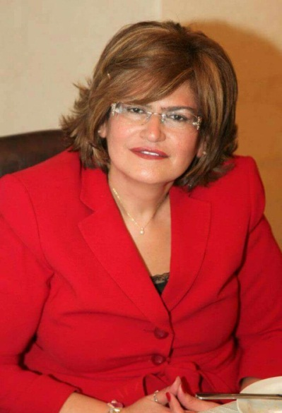

Sana Hamzeh, Psy.D, MA, BA, Working since 1986 in the field of rehabilitation, she is a founding member for Friends in Need Association for Deaf, President of FISTA Association for Special Education - North Lebanon since 1992, and a founding member in Restart Center for Rehabilitation of victims of violence and torture. In 2000, Dr. Hamzeh was a founding member in EMACAPAP - Eastern Mediterranean Child and Adolescent Psychiatric; in 2008 she was a member in IACAPP - International Association for Child and Adolescent Psychiatry and Allied Professions. She is renowned for her international expertise in the documentation of torture according to Istanbul Protocol (IP) (20 cases have been referred to the court with the collaboration of lawyers). In 2013, she has been appointed as a professional trainer in “Capacity Building for Law Enforcement Personnel in Lebanon” regarding documentation of torture according to the IP. She is also an international trainer at the forum for the monitoring of places of detention in the MENA region implemented by Dignity institute, Denmark and Restart Center, Lebanon. Recently, she has become a Health Advisory council member of the IRCT – International Rehabilitation Council for Torture Victims.

