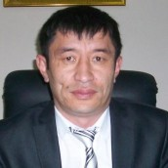

Sulaimanov Nurdin,

Director of National Center for the Prevention of Torture and Other Cruel , Inhuman or Degrading Treatment or Punishment in Kyrgyz Republic. He was , born 08.21.1978 year . He graduated from the International University of Kyrgyzstan, Faculty of Diplomacy and International Law . In the human rights sector he has been working since 2009 year. On September of 2015 participated in the international conference on children's rights in
Kazak Republic.

PRESENTATION :The Role of the National Center for Prevention of Torture of the Kyrgyz Republic in Revealing and Documenting Torture Cases.

