REPORT
of the National Center of the Kyrgyz Republic for the Prevention of Torture and Other Cruel, Inhuman or Degrading Treatment or Punishment for 2023

Table of Contents

INTRODUCTION 3
SECTION 1. ACTIVITIES of the NATIONAL CENTER in 2023 4
SECTION 2. OVERVIEW OF THE SITUATION OF THE RIGHT TO FREEDOM FROM TORTURE AND ILL TREATMENT IN THE KYRGYZ REPUBLIC 9
2.1 THE RIGHT TO FREEDOM FROM TORTURE AND ILL-TREATMENT IN CRIMINAL PROCEEDINGS 9
A. Pre-investigation stage ..…………………………………………………..12
B. Investifation stage..……………………………………………………….. 18
C. Trial stage…………………………………………...… …….21
D. Stage of Sentence Execution……………………………………….…. 24
2.2 THE RIGHT TO BE FREE FROM TORTURE AND ILL-TREATMENT IN HEALTH CARE INSTITUTIONS 28
2.3 THE RIGHT TO FREEDOM FROM TORTURE AND ILL-TREATMENT IN SOCIAL RESIDENTIAL INSTITUTIONS 30
2.4 THE RIGHT TO FREEDOM FROM TORTURE AND ILL-TREATMENT IN CHILDREN'S BOARDING INSTITUTIONS 32
2.5 THE RESULTS OF A SURVEY OF SERVICEMEN PERFORMING COMPULSORY MILITARY SERVICE IN MILITARY UNITS WITH REGARD TO THE OBSERVANCE OF THE RIGHT TO FREEDOM FROM TORTURE AND ILL-TREATMENT 33
SECTION 3. RESULTS OF REVIEW OF Allegations of torture, ill-treatment and statements of the NATIONAL CENTER in 2023 34
3.1 RESULTS OF THE REVIEW OF ALLEGATIONS OF TORTURE AND ILL-TREATMENT REPORTED TO THE NATIONAL CENTER IN 2023 34
A. Allegations of torture ………………………………… 34
B. Allegations of ill-treatment ……………………………………… 38
3.2 RESULTS OF REVIEW OF STAEMENTS BY THE NATIONAL CENTER ON VIOLATIONS REVEALED IN 2023 39
SECTION 4. SYSTEMIC CAUSES OF TORTURE 40
CONCLUSIONS AND RECOMMENDATIONS 47
FINANCIAL REPORT OF THE NATIONAL CENTER for 2023 50

INTRODUCTION
This report has been prepared in accordance with the requirements of Article 15 of the Law of the Kyrgyz Republic “On the National Center of the Kyrgyz Republic for the Prevention of Torture and Other Cruel, Inhuman or Degrading Treatment or Punishment” (hereinafter - the Law on the National Center) and Paragraph 3, Article 130 of the Law of the Kyrgyz Republic “On the Rules of Procedure of the Jogorku Kenesh of the Kyrgyz Republic”.
The annual report is based on the overall practice of the National Center, official data of state bodies and analytical materials. The report includes a general overview of the situation with torture in the country, information on measures taken by the State to eradicate systemic causes in the area of guaranteeing the right to freedom from torture, and also reflects the level of implementing the recommendations of the National Centre and international organizations. The report highlights violations of the provisions of the Law on the National Center by individual state bodies, describes challenges faced in implementing the mandate of the National Center.
The Kyrgyz Republic has ratified a number of international human rights treaties, including the UN Convention against Torture and Other Cruel, Inhuman or Degrading Treatment or Punishment and the Optional Protocol to this Convention. As part of the obligations under the Optional Protocol, a national preventive mechanism, a new independent state body in the field of protection of human rights to freedom from torture - the National Center of the Kyrgyz Republic for the Prevention of Torture and Other Cruel, Inhuman or Degrading Treatment or Punishment (hereinafter - the National Center, NCPT) - was established in 2012.
The year 2023 was marked by the Jubilee Year of Human Rights. On December 6, 2023, in Bishkek, the National Center, together with the Regional Office of the United Nations High Commissioner for Human Rights in Central Asia, held a commemorative event to mark the 75th anniversary of the Universal Declaration of Human Rights.
The State is taking steps to combat torture. Nevertheless, the practice of physical violence and psychological pressure in places of deprivation and restriction of liberty continues to date. Deaths in closed institutions are of particular concern. Despite the measures taken to improve detention conditions, it is still too early to speak of systemic changes and the creation of conditions in places of deprivation and restriction of liberty that meet international and national standards.
The National Center in its annual reports has repeatedly reported violations of the Law in terms of obstruction of activities. The Jogorku Kenesh of the Kyrgyz Republic in the respective resolutions stated about the elimination of the facts of obstruction and interference in the activities of the National Center. However, such violations are still taking place. Thus, in 2023, six facts of obstruction were recorded. This violation is facilitated by the exclusion of criminal and administrative liability from the legislation in 2019, the resulting conflict between the respective norms of the existing codes and Article 18 of the Law on the National Center, and, as a consequence, the impunity of the perpetrators of obstruction.
In order to effectively implement the recommendations of the National Center, as reflected in the Parliament's resolutions, as well as the recommendations of international human rights bodies regarding Kyrgyzstan, the activities of interdepartmental working groups continued in 2023, in close cooperation with representatives of State bodies.
The first section of this report provides information on the activities of the National Center and main statistical data for 2023.
The second section contains general information on the situation with the right to freedom from torture and ill-treatment in the Kyrgyz Republic at different stages of criminal proceedings, conditions of detention in institutions under the jurisdiction of relevant ministries and agencies, and the results of the survey of conscripted military personnel.
The third section provides the results of reviewing allegations of torture and ill-treatment, and the acts of violations identified by the National Center in 2023.
The fourth section of the report is focused on the systemic causes of the continuing practice of torture and ill-treatment and recommendations to address them.
The final section presents conclusions and recommendations to the relevant state bodies on improving the situation on eradication of torture and ill-treatment.
The financial report of the National Center for 2023 is attached to the report.

SECTION 1. ACTIVITIES of the NATIONAL CENTER in 2023

In 2023, the National Center conducted 879 preventive visits to places of deprivation and restriction of liberty including 836 special visits, 30 comprehensive visits, and 13 intermediate visits..

Figure 1: Number of preventive visits conducted in 2023, by province

Figure 2: Number (%) of preventive visits to places of deprivation and restriction of liberty conducted in 2023, by jurisdiction

Despite repeated recommendations of the National Center, stated in the annual reports of the NCPT and resolutions of the Jogorku Kenesh of the Kyrgyz Republic, to eliminate obstruction and interference in the activities of the National Center, such violations continue to date.

Figure 3: Number of cases of obstruction of the National Center's activities recorded in 2023, by region

All the facts of obstruction were reported to the prosecutor's office, and as a result, no official was duly punished.
The National Center prepared 142 reports on violations of the norms of national legislation and standards of humane treatment and conditions of detention in closed institutions revealed during preventive visits in 2023.

Figure 4: Number of National Center reports prepared in 2023, by province

Figure 5: Number of National Center reports prepared in 2023 in different institutions, by jurisdiction

In 2023, 167 applications were received, of which 59 complained of torture, 38 of ill-treatment and 22 of unsatisfactory conditions of detention. During the year, the National Center received 140 citizens who sought assistance on various issues, and provided more than 200 consultations.

Figure 6: Number (%) of applications received by region

In order to effectively implement the recommendations of the National Center, reflected in the Resolution of the Jogorku Kenesh of the Kyrgyz Republic dated 16 June 2022 № 318-VII, the creation of an interdepartmental working group was initiated consisting of employees of the National Center and relevant government agencies. Within the framework of this activity, a number of working meetings and three round tables were held.
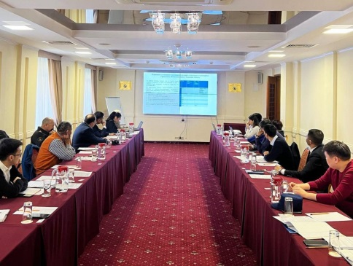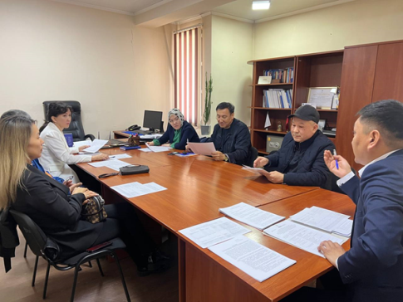

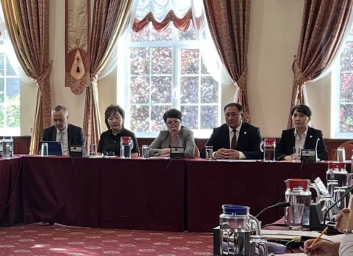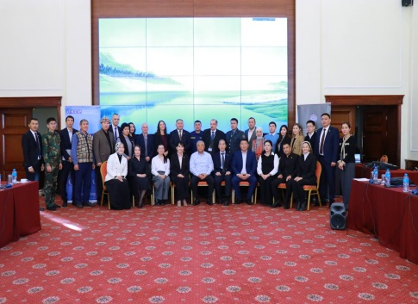
Photo 1, 2, 3, 4. Extended meetings of the interdepartmental working group on the implementation of the recommendations of the National Center set out in the resolutions of the Jogorku Kenesh of the Kyrgyz Republic. Bishkek, 11 March, 6 April, 29 August and 30 November 2023.

Owing to the effective activity of the interdepartmental working group, the following results were achieved:
- The Ministry of Labor, Social Welfare and Migration of the Kyrgyz Republic (hereinafter - MLSWM) issued Order No. 93 dated 21 June 2023 “On Approval of the Instruction on Immediate Notification of the National Center on the Facts of Death of the Recipients of State Services in Social Inpatient Institutions and Rehabilitation Centers”.
- The Ministry of Internal Affairs of the Kyrgyz Republic (hereinafter - MIA) issued Order No. 478-rot dated 30 May 2023:
- “On the Organization of Access Control within the High Security Facility of the Internal Affairs Bodies, to include unimpeded access of the National Center's employees to the High Security Facility of the Internal Affairs Bodies”,
- “On immediate notification (within two hours) of the National Center on the deaths of persons held in TDFs or institutions of internal affairs bodies”.
- (c) The Sentence Execution Service under the Ministry of Justice of the Kyrgyz Republic (hereinafter referred to as SIN) approved an Order dated 18 May 2023, according to which the following duties are assigned to the respective employees of the subordinate institutions:
- notify the National Center no later than two hours from the determination of a person's death;
- provide the National Center with unimpeded access to the institution;
- at the written request of the National Center, provide the necessary information.
- The Ministry of Digital Development of the Kyrgyz Republic has strengthened the work on registration and documentation of convicts. In particular, each Population Service Center (PSC) in the country has a separate “window” to receive documents for convicts in order to obtain a birth certificate or a passport, or disability certificate. In addition, a mobile group for documentation of convicts has been established, whose tasks include visiting SIN institutions on a monthly basis.
The National Center is actively working within the framework of the Coordinating Council on Human Rights under the Cabinet of Ministers of the Kyrgyz Republic, established in 2013, making proposals on the prevention of torture and improvement of conditions in closed institutions.
In 2023, together with the Coalition against Torture in Kyrgyzstan, with the support of the OSCE Program Office in Bishkek, the second stage of the special study “Atlas of detention conditions of suspected and accused of committing crimes in temporary detention facilities of internal affairs bodies” was conducted. The study results make it possible to monitor the dynamics of observing the rights of persons held in pre-trial detention facilities.
In 2023, the National Center submitted an alternative report to the UN Committee on the Rights of the Child, which highlighted the current problems in the implementation of the provisions of the respective Convention.
One of the main tasks of the National Center is to develop and implement awareness-raising and educational activities aimed at eliminating the causes and conditions leading to the use of torture and ill-treatment. In 2023, the National Center's employees conducted 65 lectures, 16 seminars, 15 trainings, 11 round tables and 6 conferences. In addition, more than 40 publications were published on the official website and social network pages of the NCPT, and interviews were given in the media.
On 27 June 2023, together with the Coalition against Torture in Kyrgyzstan, with the support of the Regional Office of the UN High Commissioner for Human Rights for Central Asia (hereinafter - UN OHCHR), a round table “Kyrgyzstan on the Way to Eradicate Torture: Problems, Achievements and Prospects” was held on the occasion of the International Day in Support of Victims of Torture.
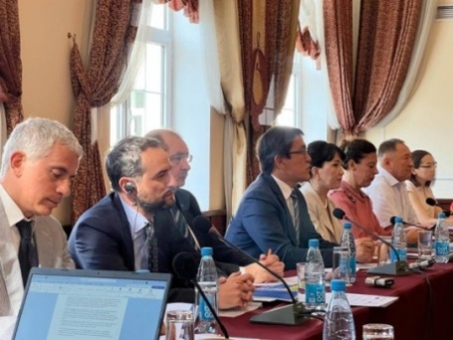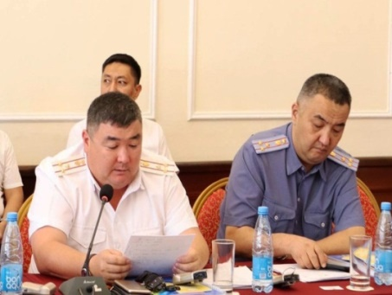
Photo 5, 6. Conference “Kyrgyzstan on the Way to Eradicate Torture: Problems, Achievements and Prospects”. Bishkek, 27 June 2023
On 9 June 2023, within the framework of the awareness-raising campaign “Unite Against Violence”, the National Centre and the Coalition against Torture in Kyrgyzstan, with the support of the OSCE Program Office in Bishkek, organized an intellectual and entertaining game Quiz Night, with the participation of 14 teams represented by government agencies, non-governmental organizations and the media.
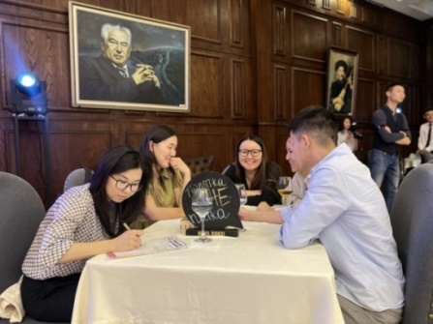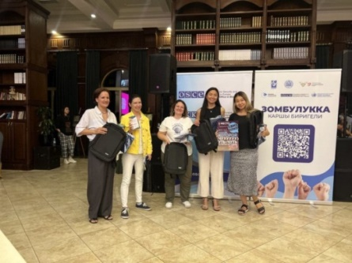
Photo 7, 8. Intellectual and entertaining game Quiz Night. Bishkek, 9 June 2023
On 6 December 2023, the National Center, together with the UN OHCHR, held a ceremonial event dedicated to the 75th anniversary of the Universal Declaration of Human Rights “Implementation of the Action Plan of the Kyrgyz Republic on Human Rights for 2022-2024”.
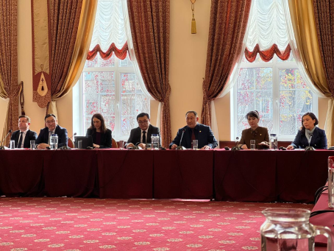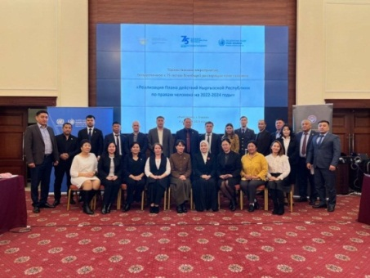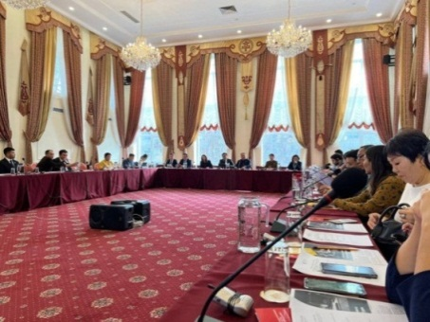
Photo 9, 10, 11. Ceremonial event dedicated to the 75th anniversary of the Universal Declaration of Human Rights. Bishkek, 6 December 2023
On 22 November 2023, the National Center and the Coalition against Torture in Kyrgyzstan, with the support of the OSCE Program Office in Bishkek, conducted a round table to discuss the results of a special study of detention conditions in TDFs and places of detention of internal affairs bodies. The event was attended by heads of temporary detention facilities, Ministry of Internal Affairs officials, and representatives of international and national human rights organizations.
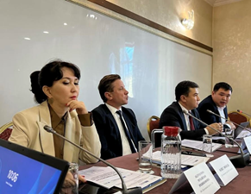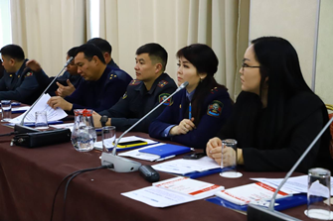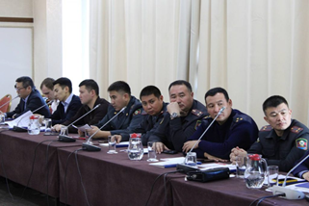
Photo 12,13,14. Round table to discuss the results of a special study of detention conditions in TDFs of IAB and places of detention of internal affairs bodies. Bishkek, 22 November 2023.
In March 2023, the National Center, together with the public foundation “Bir Duino - Kyrgyzstan”, developed and submitted to the UN Human Rights Council a brief review on the promotion of the Universal Periodic Review in Kyrgyzstan.
During July-August 2023, the National Center, with the support of the Geneva Center for Security Sector Governance, conducted a survey of conscript soldiers to determine the level of respect for civil, political, economic and social rights during their compulsory military service.
In cooperation with the Association for the Defense of Human Rights in Criminal Proceedings “Article-9”, six policy papers were prepared on the following topics:
- “Issues of Ensuring the Rights of Persons with Serious Diseases Detained in Institutions of the Sentence Execution Service under the Ministry of Justice of the Kyrgyz Republic”,
- “Mortality in the institutions of the Sentence Execution Service under the Ministry of Justice of the Kyrgyz Republic”,
- “Experience of Kyrgyzstan in Implementing the Principles of the “Istanbul Protocol”: Results and Prospects”,
- “Problems Women Face in Criminal Proceedings”,
- “Violation of the detention period for suspects and first-time detainees in temporary detention centers of the Ministry of Internal Affairs of the Kyrgyz Republic”,
- “Issues of Compensation and Reparation for Victims of Torture in the Kyrgyz Republic”.
Also, with the support of Article-9, six thematic special reports on pressing socially important topics and violations of the law were prepared:
- “Transfer of the SIN medical service to the jurisdiction of the Ministry of Health”,
- “The Day Lasts More Than a Hundred Years...”,
- “Preventive measure”,
- “Offense and Punishment”,
- “Impunity and collective responsibility”,
- “Collectors”.

SECTION 2. OVERVIEW OF THE SITUATION OF THE RIGHT TO FREEDOM FROM TORTURE AND ILL TREATMENT IN THE KYRGYZ REPUBLIC

THE RIGHT TO FREEDOM FROM TORTURE AND ILL-TREATMENT IN CRIMINAL PROCEEDINGS

International law prohibits torture, including in situations of armed conflict or emergency, without any exception. To date, serious steps have been taken to establish a legal framework to ensure the prohibition of torture and punishment for its perpetration. Nevertheless, torture and ill-treatment have not been eradicated and continue to be practiced with impunity.
A study conducted in 2022 in temporary detention facilities of internal affairs bodies and SIN pre-trial detention centers confirmed the scale of the problem, in particular, every fifth (20.6%) respondent in detention stated that he or she had been subjected to torture and ill-treatment. The results of the study also showed that in most cases (81.6%) torture is used to obtain confessions. The most frequently mentioned methods of torture are: beating with hands and feet, strangulation with cellophane bags, use of electric current, pouring cold water on them, rape with a police truncheon or threat of such, as well as various methods of psychological violence.
A big problem remains the process of issuing a ruling not to initiate a criminal case on the fact of torture and appealing it to the judicial authorities. This process can protract for several years if a judge recognizes the investigator's ruling on refusal to initiate a criminal case as illegal and unjustified, after which the investigator again issues the same ruling.
In all the cases that were studied, not a single law enforcement officer was suspended during the inspection. And this is justified since the pre-investigative inspection is conducted without initiating a criminal case. Such an attitude of investigators gives an opportunity to law enforcement officers, who allegedly used torture, to put pressure on the victim of torture, using their official position. Full-fledged measures to interview witnesses and preserve medical evidence were not carried out, and the time limits for preliminary check were artificially exceeded.
In addition, during the investigative actions in the course of pre-trial proceedings in an initiated criminal case, the victim takes part in more than 50 per cent of the investigative actions - forensic medical, forensic psychological, complex forensic psychological and psychiatric examinations; interrogations; face-to-face confrontation; inspection of the scene of the incident; taking testimony on the spot, etc. In the course of pre-trial proceedings, the procurator or investigator sends information to the institution against whose officers the complaint was filed, with a request to conduct verification of the fact of torture mentioned in the complaint. In such a situation, the victim of torture is forced to meet with the officers who tortured him/her, which causes repeated stress, pressure and a feeling of helplessness.
The analysis of existing problems in the consideration of criminal cases of torture is presented below and recommendations for their solution are provided.
- The criminal legislation of the Kyrgyz Republic does not provide for the possibility of applying international human rights treaties
The Kyrgyz Republic has undertaken international obligations on the absolute prohibition of torture and the implementation of appropriate anti-torture policies at the national level. Thus, Article 7 of the International Covenant on Civil and Political Rights establishes absolute prohibition of torture and ill-treatment. According to this prohibition, no reason, including an order from a superior person or a representative of State Authority, may be invoked to justify torture. The Constitution of the Kyrgyz Republic guarantees the absolute prohibition of torture and inhuman treatment of anyone (Article 56). The Criminal Code criminalizes the use of torture (Article 137).
The provisions of the normative legal acts of the Kyrgyz Republic governing criminal proceedings are applicable only if they are incorporated into the Criminal Procedure Code. It is clear from the meaning of Articles 1 and 2 of the CPC that the Constitution is directly applicable and the CPC is based, inter alia, on international norms and treaties. However, there is no mention of any of their effect. Article 3 of the CPC excludes the possibility of applying the provisions of national laws regulating the procedure of criminal proceedings without incorporating them into the Code.
Article 2 Part 2 of the CPC contains a caveat: “Criminal proceedings in the territory of the Kyrgyz Republic, regardless of the place where the crime was committed, shall be conducted in accordance with this Code, unless international treaties of the Kyrgyz Republic establish other rules for the operation of this Code in space”. However, this caveat is made exclusively with regard to the effect of the Code in space, which, in its turn, implies peculiarities of applying measures of criminal impact on foreigners, stateless persons, representatives of international organizations and diplomatic services. This part is also confirmed by Article 4 of the CPC.
Thus, it can be concluded that international human rights treaties, principles and norms cannot be applied in criminal proceedings if they are not reflected in them at the time of considering the case.
- Between the time of reporting a crime and before pre-trial proceedings start, there is an additional mechanism for filtering allegations in the form of the Information Logbook
A victim of torture may file a complaint with the prosecutor's office, internal affairs bodies and national security bodies. Under Article 98 Part 4 Paragraph 9 of the Constitutional Law “On Prosecutor's Office”, military servicemen, persons liable for military duty, persons called up for training and persons who have been subjected to torture by national security officers shall file a complaint with the Military Prosecutor's Office.
In national legislation, the minimum requirements to be undertaken by an investigator or prosecutor on any report of a crime are set out in Article 153 of the CPC. Further investigative actions are possible only after a criminal case has been initiated. A decision to institute criminal proceedings or to refuse to institute criminal proceedings must be taken immediately, but no later than 10 days from the date of registration of the reason for the initiation of pre-trial proceedings. If it is impossible to take a decision within the specified period, this period may be extended by the prosecutor up to 20 days by a substantiated decision of the investigator.
It is important to note some aspects of legislation and practice leading to the possibility of concealing reports of crime, including torture. Thus, according to Article 144 of the Criminal Procedure Code, “Pre-trial proceedings are carried out in the form of pre-investigation check and investigation. Pre-trial proceedings begin from the moment the information is entered in the Unified Crime Register before the case is sent to court, the criminal case is terminated or the criminal case is dismissed”.
The procedure of Registration in the UCR is regulated by the Temporary Regulation “On the Unified Crime and Misdemeanor Register”, which introduces an additional possibility of preliminary check of completing the Information Register (IR). Thus, in accordance with Paragraph 7 “Law enforcement officials (Duty Officer and Assistant Duty Officer) receive information about any incident, including a crime or misdemeanor, and record it in the Information Register ...” and with Paragraph 13, the Prosecutor, the Head of the Investigative Unit, the Head of the Inquiry Body, in accordance with the competence established by the CPC, and the law enforcement official shall ensure the immediate transfer to the Prosecutor, the Investigator, the authorized person of the Inquiry Body of the information recorded in the Information Register of a crime or misdemeanor who, in accordance with Article 149 of the Criminal Procedure Code, must enter the information into the UCR without delay, within 24 hours at the latest. According to Paragraph 14, if the information about a crime or misdemeanor recorded in the Information Register does not contain signs indicative of a crime or misdemeanor committed, or it is not confirmed upon verification by the relevant authorized official of the inquiry body, investigator, prosecutor, one of the following decisions shall be made within 24 hours (from the moment of registration in the Information Register): 1) on the basis of a report of a law enforcement official, with the consent of the Head or Deputy Head, it shall be left without consideration and kept in the nomenclature file (order) together with supporting documents..
Thus, in cases where information about torture is entered into the IR, the person who has registered the information has a real opportunity to write off the case to the nomenclature internally, even before the start of pre-trial proceedings. The existence of such an opportunity does not allow participants in criminal proceedings to gain access to the case file, appeal against actions and have other rights provided for by the criminal procedure legislation. Also, pursuant to Article 40 of the Criminal Procedure Code, “The rights and obligations of a victim arise for a person or legal entity from the moment a ruling is issued to recognize him or her as a victim ... An investigator or a court must recognize a person as a victim from the moment of receipt of a statement that a crime has been committed or an application to consider a person as a victim”. Due to the abovementioned, when registering the application in the IR and writing off the case to the nomenclature, the applicant is actually deprived of the rights of a victim.
Conclusions:
- Criminal legislation does not provide for the possibility of applying international human rights treaties in criminal proceedings.
- From the moment of the reporting of a crime and before the start of pre-trial proceedings, there is an additional mechanism for filtering allegations in the form of an IR. This stage of checking crime/allegation/incident reports, which is not regulated by criminal procedure legislation, provides an opportunity for officials to conduct checks and write off cases - without the control of the investigating judge. Such a mechanism can be used as a mechanism of corruption, and it can also be used to reduce crime statistics/detection rates.
- The existence of the preliminary verification stage actually deprives the participants of criminal proceedings of procedural guarantees provided for by national legislation and international standards.
- Preliminary verification of allegations of torture is carried out for an unreasonably long time, forensic examinations are not appointed in a timely manner, when signs of bodily injuries disappear. This results in the dismissal of cases. The cycle of “verification-rejection-cancellation-verification” can last for a long time, which, in many cases, results in irretrievable loss of evidence.
- Investigation of statements about torture and ill-treatment is ineffective: the investigation lasts long and is of poor quality, trials against persons accused of torture and abuse of power are unreasonably prolonged. At the same time, retaliation against complainants is practiced.
- There is no independent body to investigate torture, which would meet the requirements of an effective mechanism of legal protection. Under Article 159 (Paragraph 6) of the Criminal Procedure Code, investigations in criminal cases involving crime against health, in particular under Article 137 of the Criminal Code (“Torture”), are conducted by investigators from the national security and internal affairs bodies, while most complaints of torture are received against internal affairs officers, and for the SCNS, due to its busy schedule and the nature of its work, torture is not a priority.
- The legislation of the Kyrgyz Republic does not fully provide for the responsibility of investigators for incomplete investigation and violation of the established timelines for investigation.

- PRE-INVESTIGATION STAGE
VIOLATION OF THE RIGHT TO FREEDOM FROM TORTURE IN RELATION TO DETAINEES ACCUSED OF COMMITTING CRIMES
During preventive visits to TDFs of internal affairs bodies, the National Center received five allegations of torture, of which one was dismissed due to the termination of the criminal case. Below is a summary of the progress in the consideration of these allegations.
- Internal Affairs Department of Jaiyl District
On 17 April 2023, the National Center received a report about torture of detainee M.D. in the Internal Affairs Department of Jaiyl District in order to obtain a confession of theft. During medical examination, the staff of this Internal Affairs Department put pressure on the medical workers and M.D. in order to conceal the fact of bodily injuries.
On 18 April 2023, M.D.'s statement was sent by the National Center to the Prosecutor's Office. At the same time, a letter was sent to the General Prosecutor's Office on the issue of guaranteeing safety of M.D. On the same day, a forensic medical experiment was scheduled, according to the conclusion of which, dated 19 April 2023, abrasions were found on M.D.'s legs and knee joints, ranging in size from 0.5 to 2.5 cm, covered with dark red crust.
However, a week later, during the pre-investigative verification, M.D. applied to the Prosecutor's Office of Jaiyl district with a counter-statement to leave his application without consideration. To determine the availability and severity of psychological harm to health, on 9 May 2023, a forensic psychological-psychiatric examination was scheduled, to which M.D. did not report.
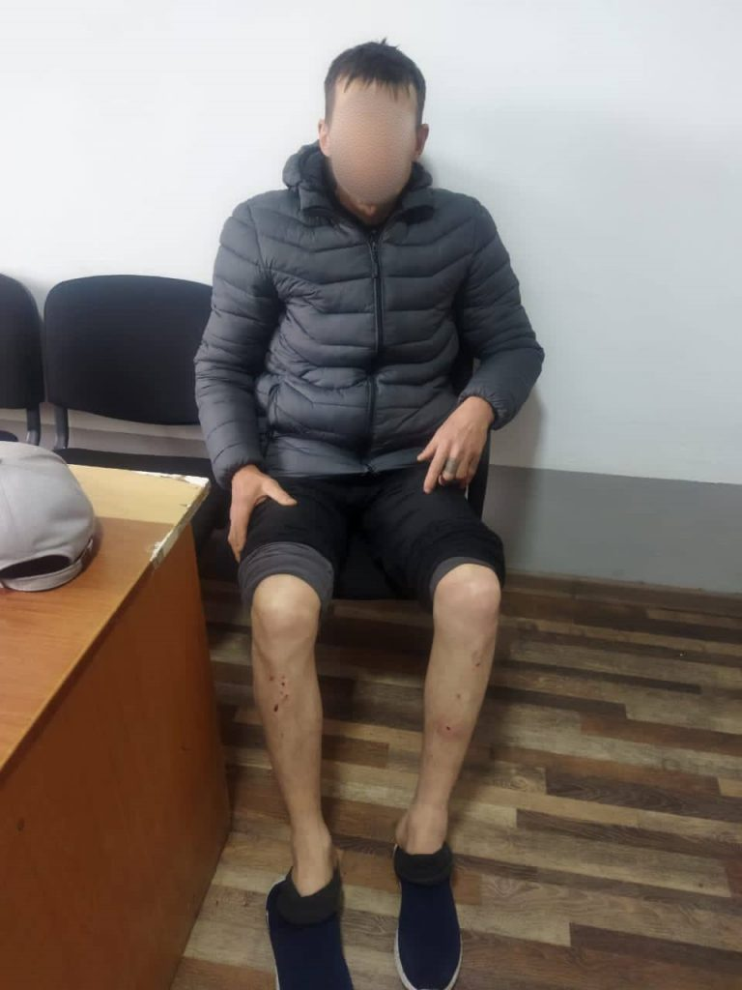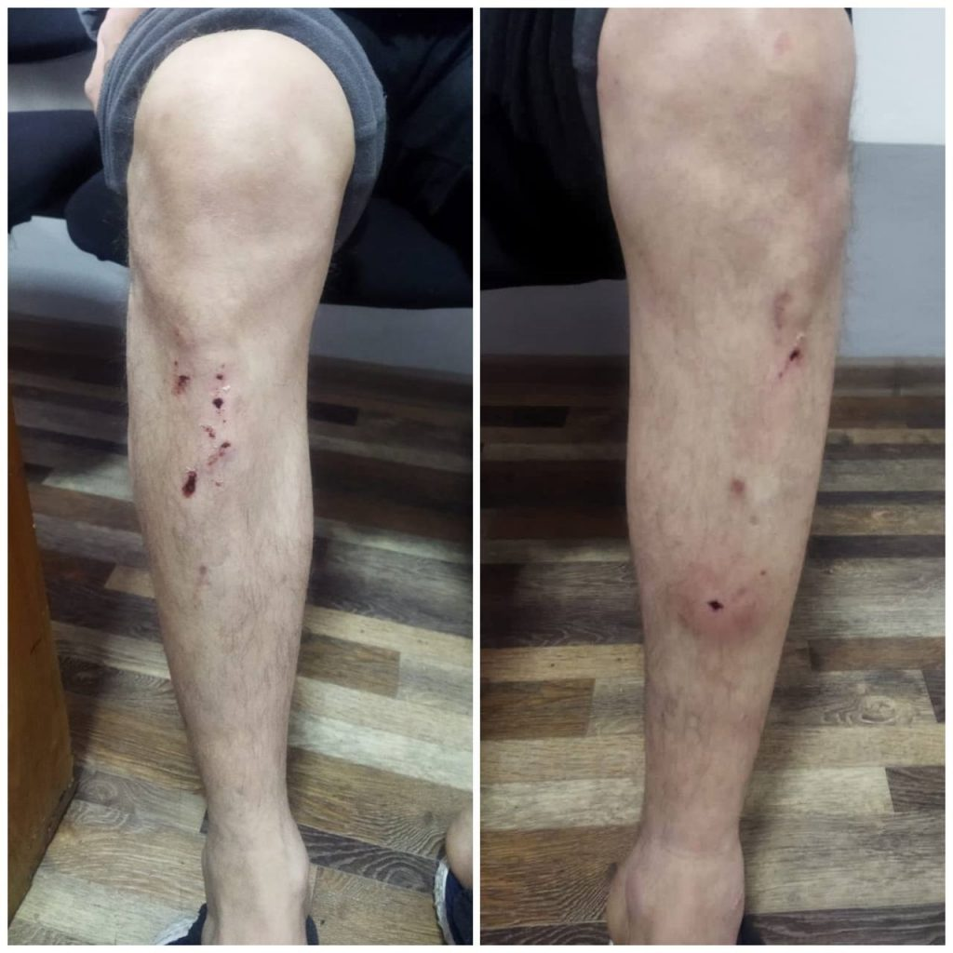
Photos 15, 16. Signs of bodily injuries on M.D.'s body.

- Internal Affairs Department of Balykchy
During a visit to the TDF of the Balykchy IAD on 11 April 2023, detainee J.E. filed a complaint of torture. He reported that he had been severely beaten by officers in the building of the Balykchy IAD. During visual examination, the National Center recorded multiple bruises and abrasions all over J.E.'s body.
The materials were transferred to the Prosecutor's Office. The investigation resulted in the refusal to initiate a criminal case on the basis of a counter-statement filed by J.E.
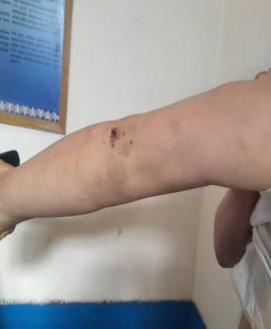
Photos 17, 18. The following bodily injuries on the body and face of J.E.

- TDF of the Osh City Internal Affairs Department
On 13 May 2023, during a visit to the TDF of the Osh City IAD, the fact of torture of A. Sh. was revealed. He reported that in the second floor office of the Osh City IAD building he was subjected to torture with a plastic bag and electric current by police officers. A.Sh. refused to submit a written statement.
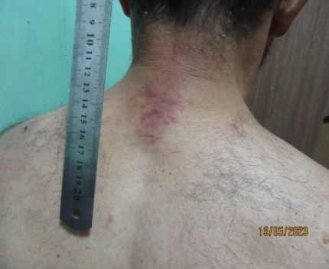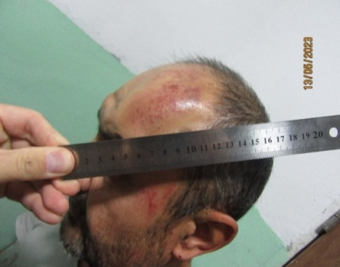
Photos 19, 20. Signs of bodily injuries on the body and head of A.Sh.

- Internal Affairs Department of Sokuluk District
On 27 July 2023, during a visit to the TDF of the Sokuluk District IAD, D.A. approached the staff of the National Center with a statement that on 20 July 2023, in the building of the Sokuluk District IAD, he was subjected to torture by police officers who put a plastic bag with a vinegar solution inside. According to him, the torture lasted from 11 at night until 4 in the morning.
The materials on this case have been transferred to the Department of State Committee for National Security in Chui Province. At the time of writing this report, according to the response of the Department of State Committee for National Security, investigative and operational activities are being carried out within the framework of the pre-investigation check, and relevant examinations have been scheduled.
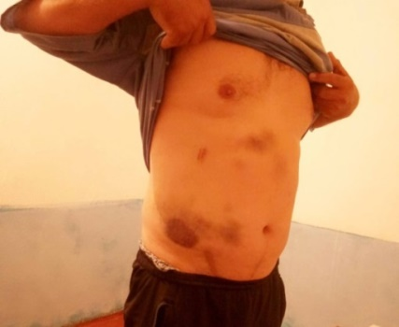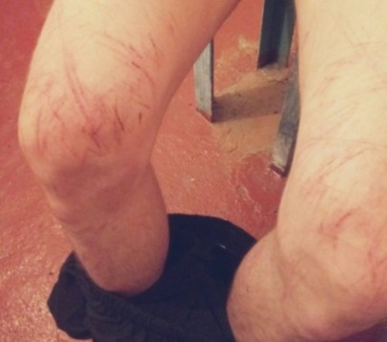
Photos 21, 22. Signs of bodily injuries on the body of D.A.

CONDITIONS OF DETENTION IN TEMPORARY DETENTION FACILITIES OF INTERNAL AFFAIRS BODIES
A total of 45 temporary detention facilities are functioning in the Republic. Seven of them (15.6%) are located in basement premises (TDFs of Kara-Suu, Sokuluk, Kyzyl-Kiya, Kadamjai, Ak-Taala, Suzak, and Naryn District IADs). Two TDFs are located in semi-basement premises (TDF of the Osh City IAD and TDF of the Ala-Buka District IAD).
A total of 45 temporary detention facilities are functioning in the Republic. Seven of them (15.6%) are located in basement premises (TDFs of Kara-Suu, Sokuluk, Kyzyl-Kiya, Kadamjai, Ak-Taala, Suzak, and Naryn District IADs). Two TDFs are located in semi-basement premises (TDF of the Osh City IAD and TDF of the Ala-Buka District IAD).
As part of the second phase of the special study “Atlas of detention conditions of suspected and accused of committing crimes in temporary detention facilities of internal affairs bodies” conducted by the National Center and the Coalition against Torture in Kyrgyzstan in 2023, 36 violations were detected, on which statements were prepared and sent to the relevant state bodies. As a result of the review, the Prosecutor's Office issued statements of prosecutor's response, requirements and instructions to the management of the Internal Affairs body. However, the statements of the prosecutor's response do not have a proper effect, as the IAD leadership recognizes them formally, considering them in a protocol procedure. In a number of cases, only a verbal warning is issued to the TDF command staff.
Main identified violations:
- temperature, humidity, lighting and ventilation standards are not observed in any TDFs of the Republic;
- there are no shower stalls in the cells;
- there are no three meals a day (except for the TDF of the Bishkek City Department of Internal Affairs);
- 13.3% of TDFs lack sanitary facilities (TDFs of Sokuluk, Issyk-Ata, Kemin, Moskovsky, Jaiyl, and Panfilov District IADs);
- 85% of TDFs do not have toilets in the cells, only 7 TDFs have toilets inside;
- 29% of TDFs do not have beds, detainees sleep on the floor or on wooden couches;
- TDF cells are not equipped with shelves, hangers, trash cans, and desks;
- 80% of antishock kits in TDFs are not fit for use;
- the exercise yards are not equipped: there are no benches or sports equipment;
- there is no ventilation and artificial lighting in the cells, there is mold on the walls and ceiling;
- there is no cold and hot water in the shower facilities;
- All TDFs completely lack any specific conditions for female detainees that would correspond to their biological characteristics and needs.
Detainees assess the detention conditions in a number of IAD TDFs as inhumane. For example, in the cells of the TDF of Sokuluk District IAD, located in a semi-basement, there are no sanitary facilities and the windows do not meet the standards. Due to the lack of glass in the window openings, the cells are very cold.
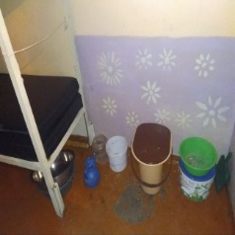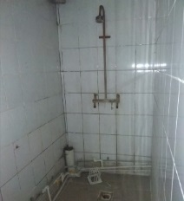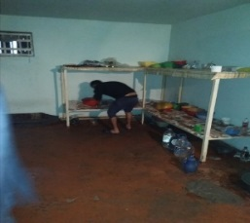
Photo 23. Buckets with a lid or bowls are used in the cells of the TDF of Sokuluk District IAD to answer the call of nature
Photo 24. Unsanitary conditions in the shower room of TDF of Sokuluk District IAD
Photo 25. A sleeping place in the cell of the TDF of Sokuluk District IAD is used for storing utensils and having meals
It was also revealed that the norm on compulsory medical examination of detainees was not complied with every time they were taken into custody, especially during initial placement in isolation cells. The maximum number of such violations was recorded in the TDF of the Jalal-Abad City IAD, where reports were prepared on the absence of medical examination of 19 detainees.
Medical examination according to Form No. 033-u is not conducted in the TDFs of the Jumgal and Ak-Taala District IADs of Naryn Province, and in the TDFs of the Leilek, Batken, Alai, and Aravan District IADs it is not performed every time a detainee is brought into the isolation ward. It was also discovered that medical staff of the territorial medical institutions of the Ministry of Health of Tokmok City and Sokuluk District did not fully fill in medical form No. 033-u (the date and place of completion, full name, stamp and signature of the examining doctor were missing).
The National Center emphasizes that, with the exception of three temporary detention facilities (TDFs of the Bishkek City Department of Internal Affairs and the TDFs of Osh and Balykchy City IADs), there are no female staff members in TDFs, which leads to gender discrimination and violation of the rights of detained women.
Only three detention facilities have a medical room. Thus, the staff of the TDF of the Bishkek City IAD and the TDF of the Osh City IAD have a medical assistant working in a medical room equipped in accordance with the standards. The TDF of the Balykchy City IAD has a medical station where a paramedic works on a part-time basis.

The National Center particularly emphasizes the gross violation related to the continuing practice of building temporary detention facilities in basement and semi-basement premises. Thus, despite the repeated appeals of the NCPT to the Prosecutor's Office of Naryn Province, a temporary detention facility is planned to be located in the basement of the new IAD building under construction.
As in previous years, there were also recorded facts of unlawful detention in TDFs for more than 48 hours, as well as incorrect application of the law on the possibility of detaining persons for up to ten days in TDFs. In particular, in the TDF of the Jalal-Abad Oblast IAD, 38 persons were found to have exceeded the detention period and one person was illegally detained.
Of particular note is a gross violation regarding the transfer of nine persons from the pre-trial detention facility of the Jalal-Abad Province Department of the National Security Committee to the TDF of the Jalal-Abad City IAD on the basis of the ruling of the investigator of the State Committee for National Security of Jalal-Abad Province agreed with the Prosecutor's Office of Jalal-Abad Province. When studying the personal files of these persons, it was revealed that a sentence has not yet been issued against them. In addition, the investigators did not specify in the rulings what investigative actions should be carried out in Jalal-Abad city for their transfer to the TDF of the Jalal-Abad city IAD, given that the pre-trial detention center of the State Committee for National Security and the TDF of the IAD are located in the same city. The response of the Prosecutor General's Office of the Kyrgyz Republic contained information The response of the General Prosecutor's Office of the Kyrgyz Republic contained information that there were no violations due to the lack of places in the pre-trial detention center of the State Committee for National Security. At the same time, the pre-trial detention center of the SCNS is intended for 28 persons, and inside the building there is a temporary detention center for four persons.
Special attention should be paid to the following violations:
- Regarding 11 persons, the detention report was prepared within three hours from the moment of actual detention.
- For three persons, the detention report was prepared within 6 to 12 hours (Kara-Suu and Nookat District IADs).
- Nine persons were kept in a car from the moment of actual detention until they were taken to the TDF and a detention report was prepared (IADs of Osh and Batken cities, IADs of Nookat, Uzgen, Kara-Suu and Leilek Districts).
- Two detainees had the procedural status of a suspect, and 12 persons were held in TDFs in the status of accused and were to be transferred to pre-trial detention facilities ( Kadamjai, Suzak, Tash-Komur, and Jalal-Abad District IADs).
- A person was held in the TDF of the Kadamjai District IAB IAD for 30 days, in the TDF of the Leilek District IAD for 42 days, and in the TDF of Uzgen District IAD for four months. The detention periods of three persons in the TDF of Batken City IAD were 25 days, 7 months and 8 days, and one year.

Conclusions of the Special Study:
- The majority of IAD TDFs in the country do not meet international and national standards to date. A number of TDFs do not comply with the recommendations of the National Center made in 2022.
- The practice of exceeding the period of detention in TDFs beyond the 48 hours provided for by law and misinterpretation of the norm on the possibility of detaining persons for up to 10 days continues.
- Not all TDFs comply with the requirement of mandatory medical examination at each admission and, especially, at the initial placement of a person in the isolation ward. Medical form No. 003-u is filled out poorly and not in full detail.
It is worth noting positive changes. During the visits, a decrease in the number of detainees' complaints about detention conditions was noted. A number of TDFs have been renovated, video cameras have been installed, taking into account all “blind zones” of the institution, sanitary equipment and heating system have been repaired, window openings have been widened, glass has been installed in windows, cell doors are being replaced, plastic utensils for eating, bedding and linens have been purchased.

CONDITIONS OF DETENTION OF PERSONS DETAINED UNDER ADMINISTRATIVE PROCEDURE
On 28 October 2021, the new Code of Offences came into force. As part of the ongoing reform of the judicial and law enforcement system, the Cabinet of Ministers approved Resolution No. 55 dated 7 February 2022 “On approval of the procedure for the functioning of places of arrest and requirements for the detention of persons subjected to arrest”. This document also approved the Procedure for the functioning of places of arrest and requirements for the detention of persons subjected to arrest.
By “arrest” is meant the detention of an offender in conditions of isolation from society, in places determined by internal affairs bodies. Under internal affairs bodies, there are established and functioning:
- IAD special reception centers for detention of persons subjected to arrest (hereinafter referred to as “special reception centers”);
- premises at the front offices of IAD territorial subdivisions for the detention of persons subjected to arrest (hereinafter referred to as “premises at front offices”).
With the adoption of the Code of Offenses, the country has toughened the punishment for minor offenses and violations, for which previously, most often, were punished with a fine. For example, administrative arrest was introduced. That is, for disobedience to the lawful request of a police officer, a person can now be arrested by court order for up to seven days. It should be noted that the period of such administrative detention before the court should not exceed three hours, but, in exceptional cases, this period can be extended up to 48 hours. Accordingly, even before a decision is taken on a person's guilt or innocence, he or she may be deprived of liberty for two days.
In 2023, the National Center, together with the Coalition against Torture in Kyrgyzstan, conducted preventive visits to 30 cells for administrative detainees and two special reception centers.
Table 1. Number of institutions covered by the study
№ | Province | Number
 |  | administrative detention cells | special reception centers
1 | Chui Province and Bishkek city | 4 | 1
2 | Osh Province | 6 | 1
3 | Jalal-Abad Province | - | -
4 | Batken Province | 4 | -
5 | Talas Province | 5 | -
6 | Naryn Province | 5 | -
7 | Issyk-Kul Province | 6 | -
 | Total | 30 | 2
The study revealed that all premises do not comply with the Procedure for the functioning of places of arrest and the requirements for the detention of persons subjected to arrest. Thus, the following violations were recorded:
- There is no drinking water in the arrest premises and there is no sanitary facility.
- Wooden couches are used as sleeping places.
- Only a mattress (in summer) and a blanket (in winter) are given as sleeping items. Often detainees use blankets left by detainees previously held in the cell.
- The heating and air ventilation systems do not ensure the necessary microclimate of the premises.
- The level of natural and artificial lighting does not meet the standards.
- Meals in the regions are given once a day.
An example of unsatisfactory detention conditions is the arrest cell of the Internal Affairs Department of the Sverdlovsky District of Bishkek: metal walls, lack of ventilation leads to an extreme degree of dampness with high temperatures in the room.
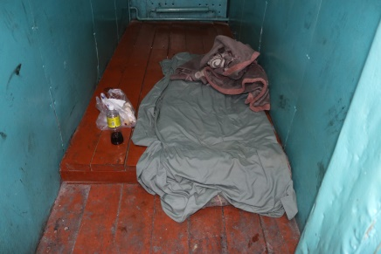
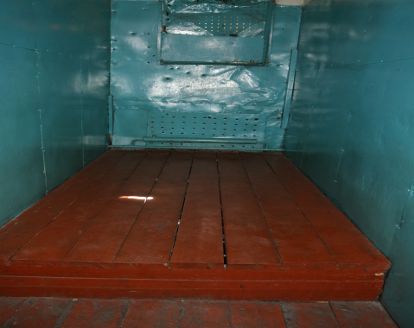

Photos 26, 27. Cells for serving arrests of the Internal Affairs Department of Sverdlovsky District of Bishkek city

According to the Center for Operational Management of the Public Security Service of the Ministry of Internal Affairs of the Kyrgyz Republic, there are 57 bodies of internal affairs in the country, each of which has administrative detention cells. In addition, there are two reception centers in the cities of Bishkek and Osh.
There are rooms in IADs, city and village police departments that were formerly used as special reception centers. Today, these rooms are not used or are not used for their intended purpose, as well as the rooms at the front offices of territorial divisions of internal affairs bodies.
For example, the premises of front offices should be equipped with at least three rooms for separate detention of persons subjected to arrest.
In fact, it can be said that only ten IADs have rooms for detention of persons subjected to arrest. At the same time, all of them, except for the Kadamjai District IAD, have only one such room.
None of the nine premises covered by preventive visits fully meets the requirements of the legislation.
Only three IADs (Nookat, Uzgen, and Leilek (Razakov) Districts) have seals, stamps, and letterheads of the established standard. Three IADs (Kara-Suu, Kara-Kuldzha and Kadamzhai Districts) did not provide information. The remaining IADs lacked seals, stamps and letterheads.
In violation of the requirements, eight IAD premises have walls adjacent to the common corridor. The exception is the Leilek District IAD, where the arrest room is not adjacent to the common corridor, but only due to the fact that the room is located in the basement.
The doors of eight premises have handles only on the outside. At the same time, in one of the premises of the Kadamzhai District IAB of the Kadamzhai region there is no handle either on the outside or on the inside of the door.
None of the doors is equipped with a viewing window. Four IAD premises for arrest (Aravan, Kyzyl-Kiya, Kadamjai and Leilek districts) have a metal door. In the premises of five IADs (Nookat, Kara-Suu, Uzgen, Kara- Kulja and Batken Districts), a metal grate is installed instead of a door.
The premises of five IADs do not have inlet and outlet ventilation.
All the premises have one couch as a sleeping place.
There is no bed linen in any of the premises. All nine premises have only a mattress as bedding, the Nookat IAD has a mattress and a blanket, and the Kyzyl-Kiya IAD has a mattress and a pillow.
There is no alarm system in the premises of three IADs.
90% of cells for administrative detainees in two provinces are located in TDF buildings, and none of them meet the requirements of the relevant regulation.
In 80% of them, one room is allocated for these purposes, which is not equipped with a bed.
There is no separate bed linens for administrative detainees; they are issued through the TDF.
It was also revealed that none of the persons serving arrest were informed about their rights, including the right to use the services of a lawyer.
Some of the interviewees reported that they were involved in cleaning the TDF premises and the exercise yard.
According to the official information of the Supreme Court, in the first 9 months of 2023, the judicial bodies of the Republic imposed penalties in the form of arrest against 1,783 people.
The National Center concludes that none of the premises under IADs for serving administrative detention meet the established requirements, and detention in such premises constitutes cruel and inhuman treatment of persons detained for administrative offenses.

- INVESTIGATION STAGE
ALLEGATIONS OF TORTURE AGAINST PERSONS UNDER INVESTIGATION AND ARREST
“The Nelson Mandela Rules” stipulate the State's obligation to treat all prisoners with respect because of their inherent dignity and their value as human beings. “All prisoners shall be treated with the respect due to their inherent dignity and value as human beings. No prisoner shall be subjected to, and all prisoners shall be protected from, torture and other cruel, inhuman or degrading treatment or punishment, for which no circumstances whatsoever may be invoked as a justification. The safety and security of prisoners, staff, service providers and visitors shall be ensured at all times.” (Rule 1).
The practice of the National Center shows that there is a violation of the right to freedom from torture and ill-treatment of persons under investigation during their detention in the isolation facilities of the criminal-enforcement system.
- Allegation of torture by SCNS officers
The National Center received a report of torture in relation to detainees held in pre-trial detention center-5 in Osh. During the visit it was found out that at 4 p.m. on 9 October 2023, employees of the national security bodies took six detainees to the building of the SCNS in Osh and at 9 p.m. brought them back to the detention center. Upon their return, the detainees were found to have numerous bodily injuries, which were recorded in the relevant documents by the medical staff of the pre-trial detention center.
During the interview, the detainees confirmed the fact of beating and torture, but refused to file a complaint.
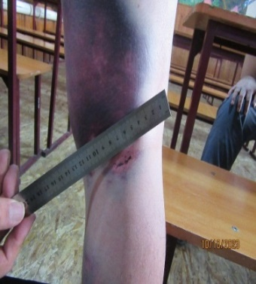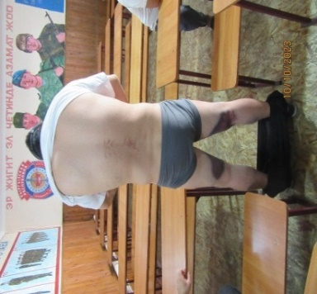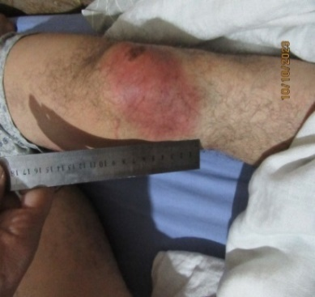
Photos 28, 29, 30. Signs of bodily injuries on the body of one of the detainees

- Statement on ill-treatment in pre-trial detention center-4
During a visit to PTDC-4 in Naryn, the defendant I.N. approached the employees of the National Center with a statement about ill-treatment by the staff of the detention facility. According to his words, on 27 April 2023, on his return from the court to PTDС-4, for the purpose of inspection he was rudely undressed outside the entrance to the premises, despite the cold weather. After the search, he received his clothes and shoes back, which had been deliberately damaged (torn) by the staff of the detention center.
I.N.'s statement was sent to the Prosecutor's Office of Naryn Province, which resulted in the refusal to initiate criminal proceedings on the basis of Article 27 of the Criminal Procedure Code.

CONDITIONS OF DETENTION IN PRE-TRIAL DETENTION FACILITIES
One of the main problems is the deterioration of buildings, structures and all types of engineering communications of penal institutions. Most of the buildings were built more than 60-70 years ago. Medical care and catering are not provided at the appropriate level. Living conditions are assessed as unsatisfactory, which is partly due to insufficient funding.
Below are examples of violations of detention standards in pre-trial detention facilities of the Sentence Execution Service.
    - Facility No. 25 (PTDC-5) Osh City
This detention center was built more than a century ago.
In the cells of PTDC-5, violations of the standards for space per detainee (3.25 square meters) were revealed. In particular, at the time of the visit there were 54 detainees in six cells with 34 beds. A report on this violation was prepared for the head of the facility.
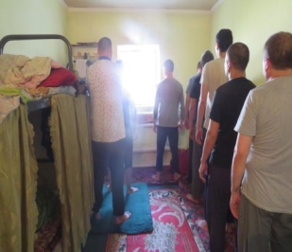
Photo 31: Overcrowded cells in pre-trial detention center-5
    - Facility No. 23 (PTDC-3) Karakol city.
As noted in previous annual reports of the National Center, the building of the detention center is in a state of emergency due to the end of the period of use. It is the oldest building in Karakol city, Issyk-Kul Province, built 105 years ago, in 1919.
Poor ventilation and air exchange in the cells has a devastating effect on the health of detainees. Natural lighting in the cells is insufficient, and artificial lighting is limited to one bulb for the whole cell. The unsatisfactory condition of toilets located in the cells of pre-trial detention facilities was noted. The flushing mechanisms of floor toilets are missing or in need of repair.
As of today, the detention facility is located in the city center, on a land plot of 0.80 hectares. The question of its transfer outside the city is urgent. This problem was raised in the annual report of the NCPT for 2021. As a result, the Resolution of the Cabinet of Ministers of the Kyrgyz Republic No. 34-r dated 13 January 2022 was adopted, protocol instructions were given to relocate the facilities of SIN No. 21, 25, 10 and 23 outside the city. On 31 March 2022, the Road Map was approved.
To date, the process of allocation of a land plot for the construction of a new building of PTDC-3 has not been completed, because there are problems with the transformation of the land plot and the long period of coordinating the utilities.
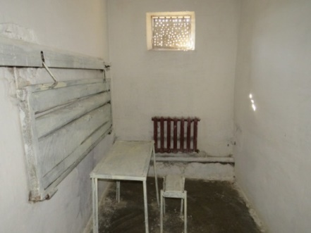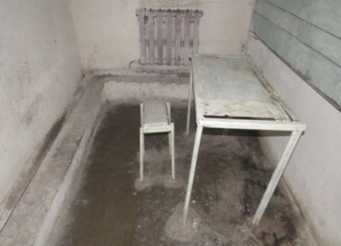
Photo 32. Punishment Isolation Cell in PTDC-3
Photo 33. Punishment Isolation Cell in PTDC-3
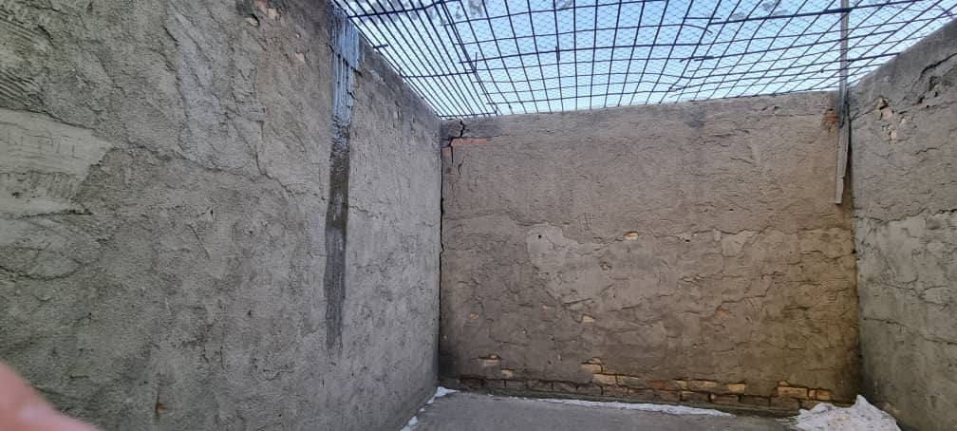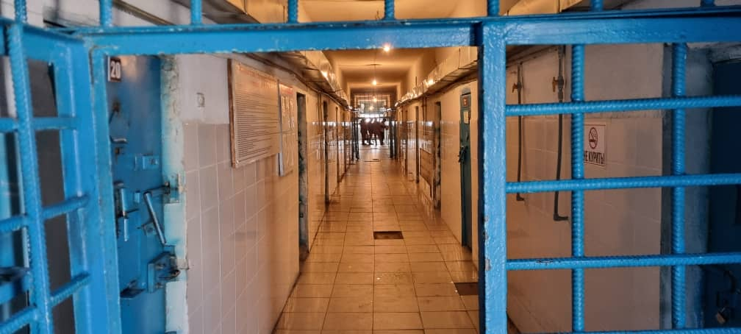
Photo 34. Walking yard in PTDC-3
Photo 35. Main building in PTDC-3
(3) Facility No. 21 (PTDC-1) Bishkek city
The National Center conducted a special visit at the request of R.D., A.B., J.M. and K.K. complaining of torture by transferring them to damp, cold cells located on the basement floor of the PTDC-1 building. It should be noted that in the technical passport of the facility this floor is indicated as the first floor, but in fact it is a basement floor.
Based on the results of the visit, a statement was prepared on the violation of detention conditions standards, in particular sanitary and hygienic norms, in the cells where the applicants were held. Thus, a high level of humidity was recorded, as a result of which the cells were damp, plaster was falling off the walls and ceilings, and there were numerous cracks in the concrete floor. At the time of the visit, 242 persons were held in such extremely unsatisfactory conditions on this floor of the detention facility.
Back in 2012, following its first visit to Kyrgyzstan, the UN Subcommittee on Prevention of Torture urged the Government of the Kyrgyz Republic to immediately close cells located in the basement and basement rooms (in TDFs, pre-trial detention centers and colonies), as and to improve conditions of detention, bringing them in line with international standards, taking into account the need to respect human dignity. However, detainees and convicts continue to be held in cells in basements and ground floors to this day.
The corresponding statement was submitted to SIN. After reviewing the statement of the National Center, the Sentence Execution Service provided a response containing information about repair work in four cells of the high-security building and “measures to maintain sanitary hygiene in the cells of the detention facility, in accordance with the daily schedule of the facility”.
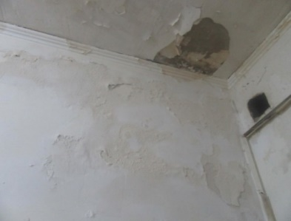
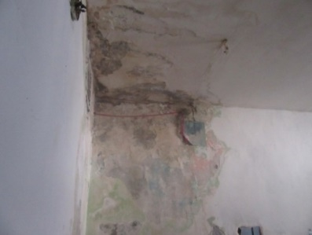
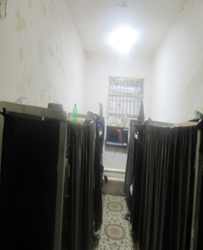
Photo 36. Cell on the basement floor of PTDC-1
Photo 37. Cell walls in PTDC-1
Photo 38. Ceiling of the cell in PTDC-1

- TRIAL STAGE
Torture and ill-treatment are used in the first hours after detention and then throughout the entire period of investigation. In most cases, detention of criminal suspects is accompanied by psychological pressure or threats, use of disproportionate force. Such actions of officials are justified and even encouraged by the relevant authorities when selecting a preventive measure. The Criminal Procedure Code provides for five types of preventive measures unrelated to detention. However, custody is the strictest measure and should be imposed in exceptional cases. However, judicial statistics for 2023 show that 95 per cent of all rulings issued resulted in the imposition of a preventive measure in the form of custody.
Allegations of torture are filed by persons under investigation and in custody. According to the National Center, in 2023 there were 9,417 people held in temporary detention isolators of internal affairs bodies, and 1,556 people held in investigative isolators of the SIN during the same period. At almost every stage, there are obstacles that prevent complaints of torture from reaching the trial stage. In addition, as noted above, the law exempts investigators from liability for incomplete checks. A significant problem is the prolonged consideration of allegations of torture, as well as untimely appointment of forensic examinations, resulting in irretrievable loss of important evidence.
The National Center receives about 200 allegations of torture and ill-treatment per year, which are forwarded to the prosecutor's office for verification. Despite exhaustive evidence in the form of photographic evidence of signs of torture, medical reports prepared in full compliance with the principles of the “Istanbul Protocol”, and witness testimonies, in 90% of cases, decisions are issued to refuse initiation of criminal cases.
At the same time, investigations are carried out only in isolated cases. According to the General Prosecutor's Office of the Kyrgyz Republic, in 2023, 126 allegations of torture and other cruel, inhuman or degrading treatment or punishment were registered in the IR AIS UCR. Based on the results of the pre-investigation inspection:
- In 104 (82.5%) cases the decision was made not to initiate criminal cases,
- 4 materials are under pre-investigation inspection,
- 18 criminal cases were initiated not under the article “Torture”, but under related, “near-torture” articles.
According to the investigation results:
- three cases have been suspended,
- two cases have been consolidated with another criminal case,
- two cases are under investigation
- 11 cases have been sent to the courts for review on the merits.
The analysis of the criminal cases of the relevant category allows us to make an unambiguous conclusion that the majority of cases of torture end with either an acquittal or release from criminal responsibility. Thus, according to the Supreme Court of the Kyrgyz Republic, from 2012 to 2023, only five criminal cases were considered in relation to 17 officials - 13 persons were acquitted and in relation to two persons criminal prosecution was terminated.
In many respects, such a situation in court is related to the high level of latency of this type of crime and the lack of an independent investigative body.
Unfortunately, the ineffectiveness of investigations into the facts of torture leads to an annual decrease in the number of complaints of torture, as victims often do not believe in the inevitability of punishment for the perpetrators. Over the last ten years, not a single official has been convicted of torture.
In addition, analysis of individual criminal cases shows that errors in the qualification of actions of persons accused of violent abuse of power are mainly related to the misunderstanding by investigators, prosecutors and judges of both subjective and objective signs of torture. In particular, the fact of using physical violence by officials is a basis for reclassifying their actions under Article 321 of the Criminal Code as “Excess of power”.
According to Paragraph 15 of the General Comments of the UN Committee against Torture, the Convention against Torture imposes international responsibility on States parties for the acts of their officials or failure to act. And in cases where investigation procedures are inadequate due to a lack of resources or expertise, bias, the apparent systematic abuse, or for any other substantial reason, States must conduct investigations through an independent investigation commission or some other similar procedure.
We note that the National Center has previously made recommendations on the establishment of an independent body to investigate torture in Kyrgyzstan.
In addition to the above-mentioned problems, the National Center draws attention to violations when courts consider the issue of changing the type of correctional facility (for example, transferring a convicted person from a correctional colony to a settlement colony), and also when granting early parole to seriously ill convicts. The following are examples.
- Case of Z.N.
Z.N., who was sentenced by the court to 15 years of imprisonment in June 2016 for committing a crime under Article 247, Part 2, Paragraph 2 and Part 3, Paragraph 4, as well as Article 249, Part 1 of the Criminal Code, is serving his sentence in Facility No. 8. In 2016, an amnesty was applied to him, on the basis of which the sentence was reduced by 1/5, i.e. by 2 years 6 months and 6 days.
The administration of the facility repeatedly appealed to the Moskovsky District Court of Chui Province with a proposal to change the type of correctional facility - to transfer Z.N. to a settlement colony, emphasizing his positive profile while serving his sentence, having two commendations and clearing all penalties. It was also stated that Z.N. had served the two-thirds of the term of imprisonment prescribed by law. The protocol of Special Commission No. 16 made a decision to approve the transfer to a settlement colony.
However, by the decision of the Moskovsky District Court of Chui Province of March 3, 2023, the submission of the administration of the facility was left without satisfaction, with reference to the fact that “the Court does not agree with the conclusions of the administration of the facility on the correction of Z.N., and if satisfied, social justice will be violated. Since the convicted person has not been engaged in social work during the sentence, is convicted for a particularly dangerous crime, has a number of penalties, and has a long period of unexecuted sentence at the time of consideration - 3 years 6 months and 2 days”.
On 20 July 2023, the Moskovskiy District Court considered a re-submission by the administration of Facility No. 8 to change the type of correctional facility of convict Z.N. and, despite the administration's arguments about the correction of the convict, by its ruling again leaves the submission without satisfaction.
It should be emphasized that the convicted Z.N., according to the medical certificate of Facility No. 8, suffers from chronic viral hepatitis C, with a transition to liver cirrhosis.
The decision of the Moskovskiy District Court of 20 July 2023 was appealed by Z.N.'s lawyer to the Judicial Board of the Chui Province Court, according to whose ruling of 20 September 2023, the court found the appeal groundless and the decision of the district court well-grounded and lawful. At the same time, the Judicial Board in the motivation part contradicts the arguments stated in the decision of the Moskovskiy District Court, referring to the fact that “The mere serving of part of the sentence by the convict cannot serve as an unconditional ground for changing the type of correctional facility, he does not need to serve the full term for his correction”. While in its ruling, the Moskovskiy District Court pointed to the long uncompleted sentence as the reason for refusal.
- Case of M.N.
M.N., who was convicted in September 2020 by the court for the crime under Article 267, Part 2, Paragraph 1 of the Criminal Code to 10 years of imprisonment with a fine of 12,000 soms, is serving his sentence in Facility No. 27. By decision of the Chui Province Court of December 3, 2021, the first instance verdict was upheld.
Since 2022, the convicted M.N. has been in a serious condition. After the surgery on removal of his left lung, the second lung started decreasing in size and is functioning at about 30%. According to the certificate of the medical unit of Facility No. 27, he was diagnosed as “Condition after pleuropulmonectomy on the left side. Respiratory insufficiency, II-III stage. Pleuropneumocirrhosis of the right lung, with a sharp decrease in its volume. Chronic hepatitis.”
In May 2022, the National Center sent letters to SIN and to the head of Facility #27 with a request to assist in sending M.N. to Medical Correctional Facility #31 to conduct a special medical commission for medical examination and submission of convict M.N. for release from further serving of sentence, based on the list of diseases approved by the Resolution of the Government of the Kyrgyz Republic dated 29 November 2011 #488.
The response of the Correctional Service dated July 26, 2022 states that on July 9, 2022, convict M.N. was admitted to medical correctional facility #31 from Facility #27 with a diagnosis of “Pleuropneumocirrhosis of the right lung. Relapse of tuberculosis, with complaints of dyspnea during fast walking and physical activity”. He received nonspecific anti-inflammatory and symtomatic treatment. On 14 June 2022, he was brought to an internal consilium. Conclusion of the consilium was “No activity of tuberculosis process”, clinical diagnosis was made “Clinical cure after pulmonary tuberculosis, with the outcome of extensive post-tuberculosis changes. Condition after pleuropulmonectomy on the right”. Convict M.N. was discharged, according to the doctors, “in satisfactory condition”, with a recommendation of observation by a doctor of the medical-sanitary unit at the place of serving the sentence. It is also stated that to date the diagnosis of convict M.N. does not correspond to the list of diseases provided for in the normative legal acts, which exempt from further serving of sentence due to serious illness.
The National Center asks to pay special attention to the above examples, which represent a systemic problem of law enforcement practice.

- STAGE OF SENTENCE EXECUTION
Conditions of detention in correctional institutions of the Sentence Execution Service under the Ministry of Justice of the Kyrgyz Republic
The problems associated with conditions in correctional colonies are similar to conditions in other correctional institutions - dilapidated buildings, deterioration of all communication systems, lack of repairs and poor funding. Below are examples of unsatisfactory living conditions in pre-trial detention centers and settlement colonies.
- Ten convicts were living in premises not intended for this purpose in the workshop No. 3 and No. 4 of SIN Facility No. 3. A report was sent to the prosecutor's office for oversight of compliance with laws in the bodies and facilities of the correctional system. At the same time, those living in the above-mentioned premises have written a statement that they live there at their own will, as they work with the administration of the facility and have no complaints about the conditions of detention.
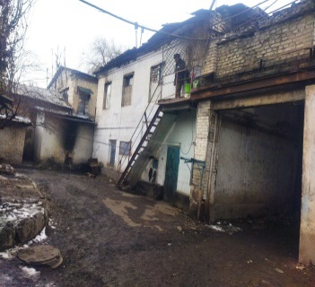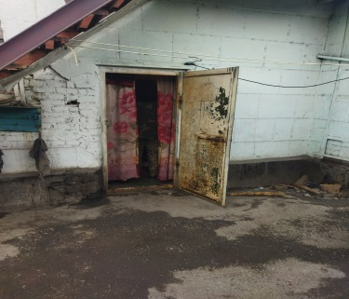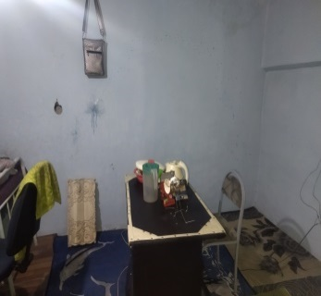
Photos 39, 40, 41. Places of residence in the industrial zone of Facility No. 3
- (2) The conditions of detention in four cells of Facility No. 14 (educational colony) do not comply with sanitary norms, and a statement to the head of the colony was prepared about it.
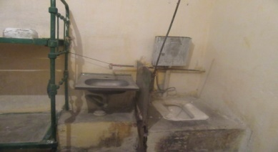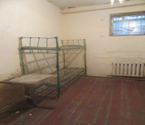
Photos 42, 43. Cameras in the Facility #14
- In settlement colony No. 39, located in Bakai-Ata District, Talas Province, most of the buildings and premises are in unsatisfactory condition, which was documented in a report.
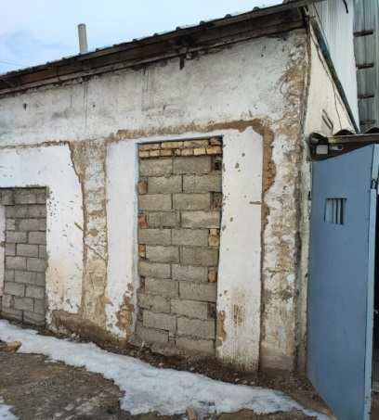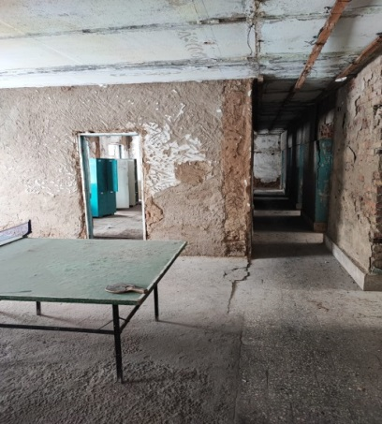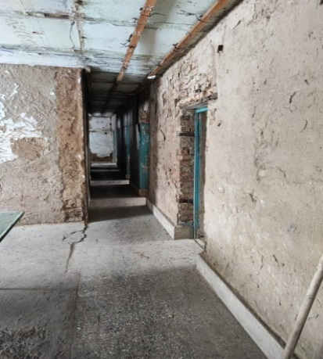
Photos 44, 45, 46. Condition of buildings and premises of settlement colony No. 39
CONDITIONS OF DETENTION IN PUNITIVE ISOLATION CELLS,
CELL-TYPE PREMISES AND PREMISES ENSURING THE SAFETY OF THE CONVICTED PERSON IN INSTITUTIONS OF THE CORRECTIONAL SYSTEM
Based on the analysis of the performed visits, it can be concluded that the conditions of detention in punitive isolation cells (PICs) and cell-type premises (CTPs) are inhuman and degrading. Most cells do not meet sanitary and hygienic standards. In a number of cells there is no washbasin faucet. Almost all the premises are in need of repair. Numerous violations of fire safety requirements have been recorded.
- Unsatisfactory conditions of detention in PIC and CTP cells in Facility No. 1 (correctional colony).
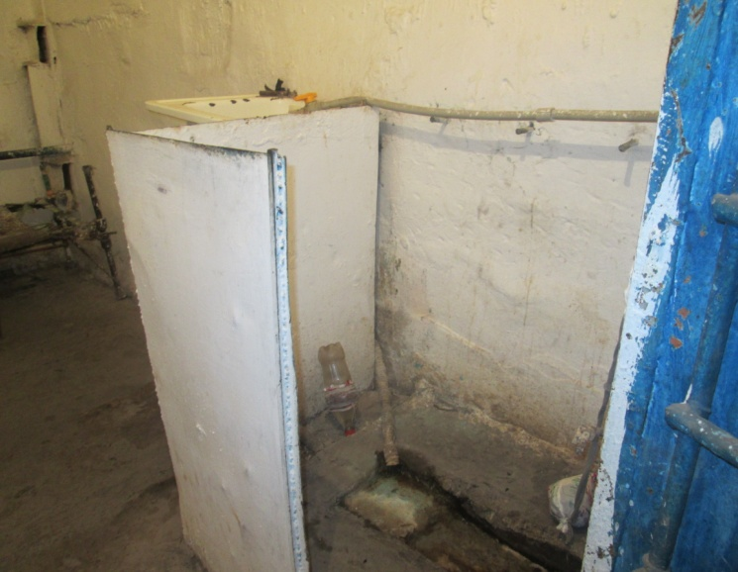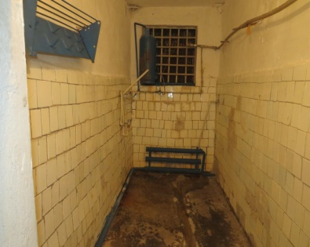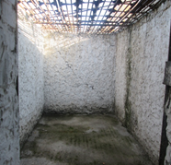
Photo 47. Bathroom in the PIC cell, CTP of Facility No. 1.
Photo 48. Shower room in the PIC cell of Facility No. 1.
Photo 49. Walking yard for detainees in the PIC of Facility No. 1
- The building of Facility No. 16 (correctional colony), where the PICs are located, is in an emergency condition. There are cracks on the walls and foundation. Extremely unsatisfactory condition of the worn-out, outdated water supply and sewerage system. Fire safety rules are not observed inside the building, and there are bare electric wires everywhere. Sanitary norms are not observed in a number of cells, windows are not covered with glass.
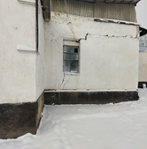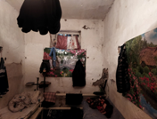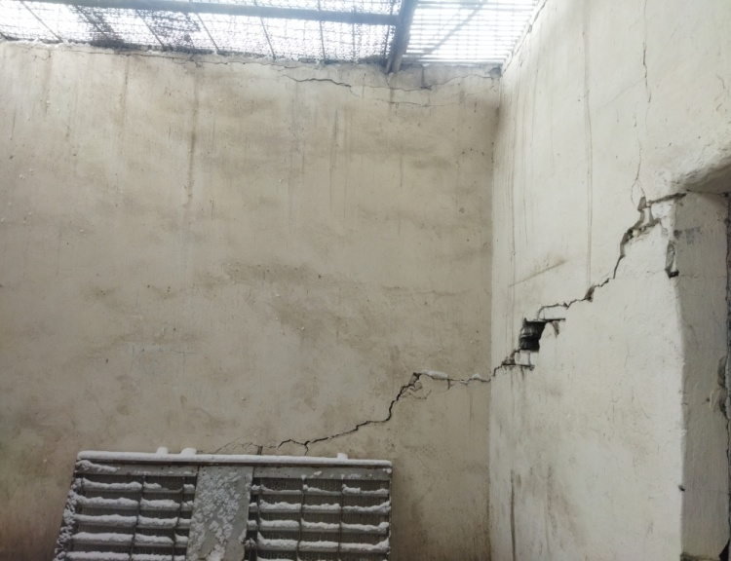
Photo 50. The building of Facility No. 16, where the PIC and CTP are located
Photo 51. CTP cell of Facility No. 16
Photo 52. Walking yard for detainees in the PIC and CTP cells of Facility No. 16
- The majority of cells, shower stalls, sanitary facilities (toilets) in the PIC cells of Facilities No. 1 and 27 are in an unsanitary condition. In a number of cells there is no washbasin faucet.
- There is no sink in the PIC of Facility No. 3. The drinking water tap is located directly above the toilet.
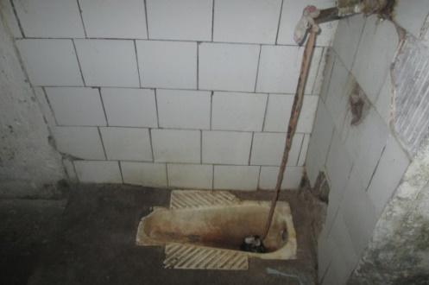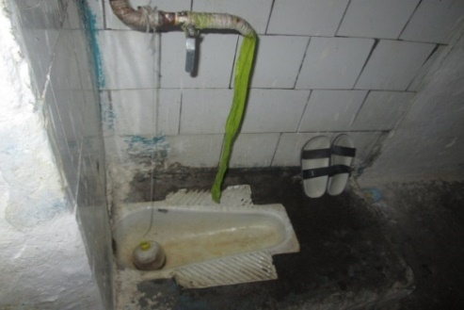
Photos 53, 54. Drinking water faucet is located above the floor sink of the toilet in the PIC cells of Facility No. 3.
- Bare electrical wires were found in many cells. There is no glass in the windows. There are no metal nets on the old, twisted beds. In some places, plaster is falling off the walls. The floors in the cells are concrete, there is no floor covering (Facilities No. 1, 8 and 27).
- Most of the exercise yards are not equipped with a shelter from rain and snow, there is no sports equipment (Facilities No. 1, 8, 31, 3, 27). There are no garbage cans and benches (institutions No. 1, 2, 8, 9, 31 and 27).
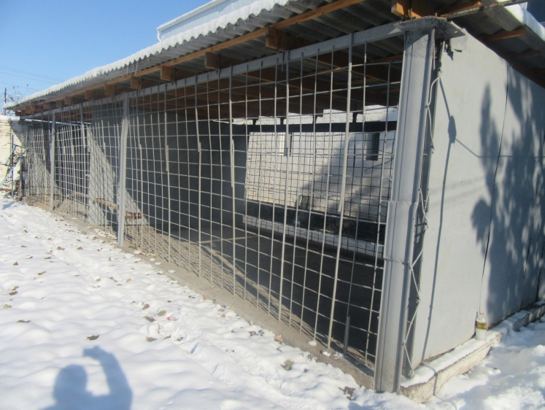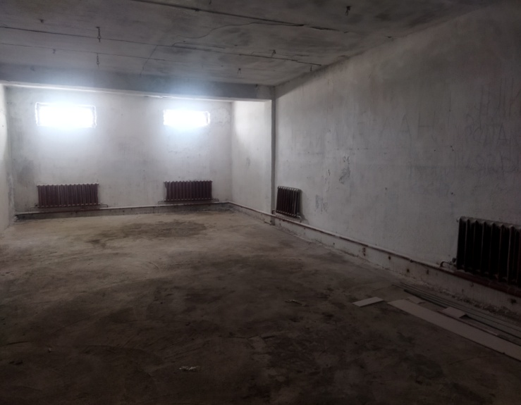
Photo 55. Walking yard for detainees in PIC and CTP of Facility No. 8.
Photo 56. Winter exercise yard for detainees in PIC and CTP of Facility No. 8.

According to SIN data, all the above violations are mainly caused by underfunding of the penitentiary system from the state budget. Thus, the allocation of funds is carried out on a leftover principle. Only in the last two years the financing of the penitentiary system has been done by 60% on average. Prior to that, for many years, the financing was carried out, on average, at 33-34% of the estimated need.

MORTALITY ISSUES AND THE RIGHT TO MEDICAL CARE FOR PERSONS HELD IN CORRECTIONAL FACILITIES
The Cabinet of Ministers was recommended by the Resolution of the Jogorku Kenesh of the Kyrgyz Republic No. 1102-VII of 19 April 2023 “On the annual report of the National Center of the Kyrgyz Republic for the Prevention of Torture and Other Cruel, Inhuman or Degrading Treatment or Punishment” to immediately inform the National Center about every fact of death of a person held in places of deprivation and restriction of liberty, regardless of the alleged cause of death.
On 18 May 2023, an Order was issued by the Chairperson of the SIN on informing the National Center about the facts of death of persons held in institutions under its jurisdiction. During 2023, the NCPT received 26 reports:
pre-trial detention centers - 5,
correctional colonies - 20,
settlement colonies - 1.

Table 2. Number of prisoners who died in 2023 in SIN facilities
№ | SIN Facility | Number of deaths
 | Facility No. 21 (PTDF-1) | 3
 | Facility No. 25 (PTDF-5) | 2
 | Facility No. 31 (Medical Correctional Facility) | 6
 | Facility No. 3 (correctional colony) | 6
 | Facility No. 8 (correctional colony) | 1
 | Facility No. 10 (correctional colony) | 2
 | Facility No. 27 (correctional colony) | 3
 | Facility No. 16 (correctional colony) | 2
 | Facility No. 43 (settlement colony) | 1
 | Total | 26

Figure 7: Number of prisoners who died in SIN institutions in 2023

During 2023, the only case of release from serving the sentence due to serious illness was recorded. Thus, B.A., born in 1971, sentenced by the court in June 2022 to nine years of imprisonment, was released on 25 October 2023 by the decision of the Alamudun District Court on the basis of Article 91 Part 1 of the CC, due to the diagnosis of “Stage IV cancer”.
However, the majority of convicts with serious diseases die in SIN institutions. Thus, of the total number of persons who died in SIN institutions in 2023, two died of terminal cancer, and two more died of liver cirrhosis, which also indicates the terminal stage of the disease. For example:
convict T.T. died on 12 May 2023 in Facility No. 10, preliminary diagnosis “Stage 4 cancer, anemia with neoplasm, ascites”;
convict B.S. died on 15 December 2023 in Facility No. 25, diagnosis “Liver cancer”;
convict T.T. died on 24 June 2023 in Facility No. 16, diagnosis “Liver cirrhosis”.
The problem of ensuring the right to life in the institutions under the jurisdiction of the penitentiary system is also acute. The system of places of deprivation of liberty has serious shortcomings related to ensuring the security of both convicts and other persons. The main condition for the security of the modern penitentiary system should be to ensure that the level of security of the place of deprivation of liberty corresponds to the degree of danger from internal and external threats. In this regard, each case of murder or suicide in SIN institutions should be investigated particularly thoroughly in order to exclude similar violations in the future.
In 2023, 5 suicides and one murder were recorded in SIN institutions.
In June 2023, the convicted underage K.I., serving his sentence in Facility No. 14 (educational colony), upon reaching the age of majority, was transferred to Facility No. 10, where two months later, on August 22, he committed suicide. While serving his sentence in Facility No. 14, K.I. was calm, balanced and did not show any suicidal tendencies. The last interview with him by the staff of the National Center was held on 25 May 2023, when he received his certificate of graduation from secondary school in Facility No. 14.
In Facility No. 3, on the night of 1 January 2023, multiple stab wounds were inflicted on T.B., a life sentence prisoner (life imprisonment), by other life sentence prisoners. T.B. died during surgery at the National Surgical Center named after M.Mamakeyev, where the convict was urgently taken from the colony. Based on the results of the official investigation, by SIN order No. 1 of 10 January 2023, disciplinary penalties in the form of strict reprimand and reprimand were issued to seven employees.
For several years, the National Center has been raising the issue of transferring the medical service of SIN to the Ministry of Health. However, this issue has not yet been resolved, and as a result, problems persist in terms of diagnosis, treatment of diseases and subsequent medical support for persons in penal institutions.
The main reasons why the medical service of the SIN is unable to provide the necessary medical care for persons under investigation and conviction are as follows:
lack of highly specialized doctors;
medical workers do not receive mandatory advanced training on an equal footing with civilian doctors, resulting in insufficient competence of the staff;
lack of opportunities to rehabilitate seriously ill patients in pre-trial detention centers and correctional facilities;
Non-compliance with treatment standards approved by the clinical protocols of the Ministry of Health.
“The Nelson Mandela Rules” require access to timely and quality health care. Ineffective medical care is regarded as cruel or degrading treatment.
Improving the quality and professional responsibility of medical staff of the penitentiary health care system, improving the quality of training of medical personnel at all levels of medical education, and the gradual transfer of penitentiary health care to the civil health care system will make it possible to achieve significant progress in health care issues in penal institutions.

THE RIGHT TO BE FREE FROM TORTURE AND ILL-TREATMENT IN HEALTH CARE INSTITUTIONS
According to the order of the Republican Psychiatric Hospital (RPH) of Kyzyl- Jar settlement dated 8 August 2022 No. 81, seven departments with a total number of 305 beds are functioning on the territory of the hospital. Previously, the structure of the hospital consisted of eight departments with a total of 325 beds. There are 110 beds for persons undergoing compulsory medical treatment, including 10 beds for women and 100 beds for men (in two wards with strict and reinforced regime).
To date, 90 patients are undergoing compulsory treatment: 41 men in ward No. 5, 42 men in ward No. 2 and 7 women in ward No. 4.
To date, the following problems remain unresolved:
- Impeding the National Center's activities by the management of the RPH Kyzyl- Jar settlement;
- geographical remoteness and isolation of the hospital;
- the stay of persons against whom a court has issued a ruling on the imposition of compulsory medical measures in a TDF or PTDC for a long period of time (more than a few months).
As an example, we can mention the fact of detention in a pre-trial detention center of two persons for whom the Jumgal District Court on 10 August 2023 and the Tyup District Court on 13 November 2023 ordered compulsory treatment in Kyzyl-Jar Regional Hospital. These persons arrived at the hospital only on 15 January 2024 and began treatment five and two months later, respectively.
There are still facts of cruel and inhuman treatment of patients in psychiatric hospitals. Thus, on 7 December 2023, C. J. applied to the National Center with a statement about the ill-treatment of her minor daughter, N., a Group 2 disabled person, by the staff of the Republican Center for Psychiatry and Narcology (RCPN) of the Ministry of Health. According to the complaint, on 4 December 2023, N. was hospitalized in Department No. 2 of the RCPN. One day later, on 6 December, C. J. came to visit her daughter and found her lying in the corridor of the department on a bed covered with plastic sheeting, without a bed sheet. C. J. decided to take her daughter to the shower, and at that time she found signs of extensive hematomas on her body on her arms, legs, the back of her neck and in the armpit area on both sides. On the same day, C.J. took her daughter home, and the hospital staff made her write a note stating that she had no claims against them.
On 8 December 2023, the staff of the National Center, together with a representative of the Ministry of Health, visited the above-mentioned department. According to the staff's words, the minor N. received bodily injuries while being restrained (physical fixation) for two hours, between 4 and 6 December 2023. However, in conversation, patients of the same ward reported that the girl was tied up twice - for the whole night of 4 and 5 December. She was seen in this position by most of the patients of the ward, some of whom gave her water.
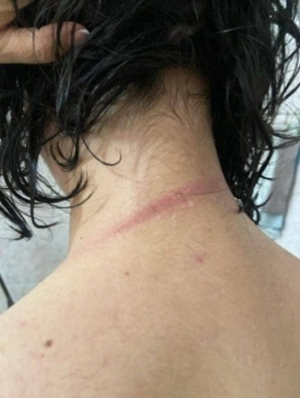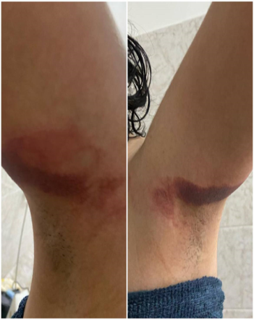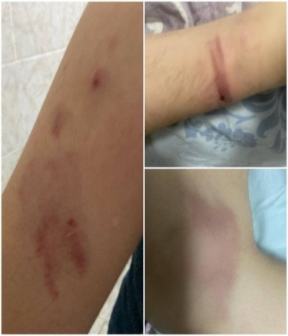
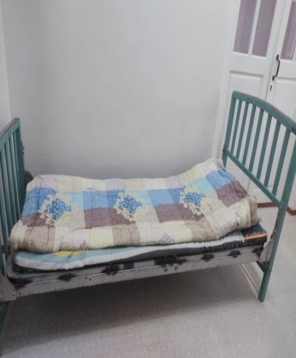
Photos 57, 58, 59, 60, 61, 62. Signs of bodily injuries on the body of minor N.
Photo 63. Bed covered with plastic sheeting without a bed sheet

The National Center sent an application to the Prosecutor's Office of Bishkek City on this fact. Also, a letter was sent to the Ministry of Health, and as a result of its consideration, the head of Department No. 2 E.B. was dismissed at her own request, based on the order of the RCPN dated 12 December 2023 № 148. It should be noted that the staff of the department did not bear any responsibility.

THE RIGHT TO FREEDOM FROM TORTURE AND ILL-TREATMENT IN SOCIAL RESIDENTIAL INSTITUTIONS
Social security is the care of the state and society for persons in need of help, assistance due to age, health, social status, insufficient means of subsistence. Social security is based on the principles of humanity, comprehensiveness and respect for human rights and freedoms.
The Ministry of Labor, Social Welfare and Migration has 17 social stationary institutions (SSIs), of which the following are in operation:
- SSIs of general type for elderly people and people with disabilities - 5,
- Neuropsychiatric SSIs for adults - 6,
- Psychoneurological SSIs for children - 2,
- Rehabilitation centers for children - 3,
- Family-type orphanage for children with disabilities - 1.
The total capacity of SSIs is 2,786 beds. As of 9 January 2024, there were 2,332 service recipients in these facilities, including 522 elderly and persons with disabilities, and 1,810 adults and children with neuropsychiatric conditions.
Below are examples of violations identified by the National Center during preventive visits in 2023.
- Kadamjai psychoneurological SSI
On 8 December 2023, non-compliance with the previous recommendations of the National Center was revealed. Thus, overcrowded living rooms, lack of heating in the women's quarters, non-compliance with fire safety, violation of sanitary and hygienic standards, availability of expired medication and food products, non-compliance with approved nutrition standards were recorded.
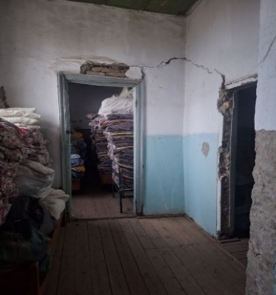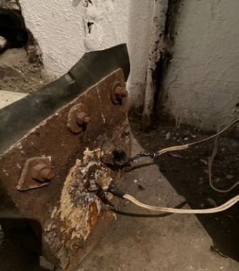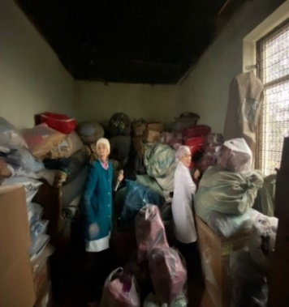
Photos 64, 65 The room is in emergency condition, bare wires
Photo 66. Disorder in the room for storing incoming humanitarian aid
Photo 67. Expired food products

In the room for women, the beds are located close to each other, which makes it impossible to put a bedside table for storing personal belongings. The temperature regime is not observed, the rooms are very cold.
Clothes are not provided according to the season, so in December the residents of the SSI were dressed lightly.
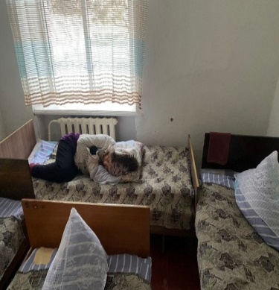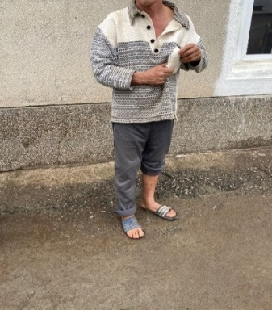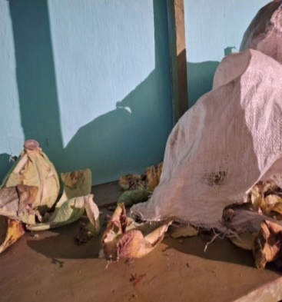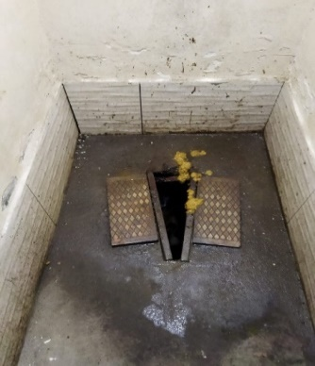
Photo 68. Women's room Photo 69. Seasonal clothes are not provided Photo 70, 71 Unsanitary conditions in the warehouse and in the restroom
Statements on all violations were sent to the prosecutor's office. As a result of the inspection, the head of the food warehouse was suspended from his post, and disciplinary penalties in the form of “reprimands” were imposed on four employees of the institution.
(2) Pokrovskoye psychoneurological SSI
On 31 May 2023, a preventive visit revealed a number of violations: unsatisfactory living conditions, expired medication, failure to distribute medication prescribed by a doctor to patients, and violation of the requirements for keeping the facility's records.
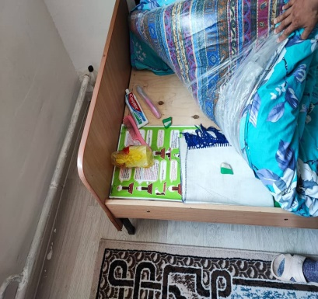
Photo 72. A toothbrush and toothpaste are stored under the mattress Photo 73. Expired medication (“Arbidol”)

The statements of violations were sent to the director of the institution. Based on the results of the internal audit, a number of employees received disciplinary actions, and the administration conducted awareness-raising activities among the institution's personnel.
- Tokmok psychoneurological SSI No. 1
In August 2023, information was published in the media about participation of Tokmok SSI service recipients in excavation works to dig a pit for a septic tank. On 8 August, during the visit of the National Center to this institution, it was found that since the beginning of construction works 13 recipients were involved in excavation of the excavation pit. At the same time, the administration of the institution formalized this fact as “labor therapy”. According to the legislation, the involvement of service recipients in occupational therapy is possible only with the permission of a doctor for a period not exceeding four hours in production workshops, clubs of different profiles and farms. Excavation of the foundation pit by the nature of the work belongs to the category of heavy physical labor and cannot be referred to “labor therapy”.
The collected materials were submitted to the prosecutor's office.
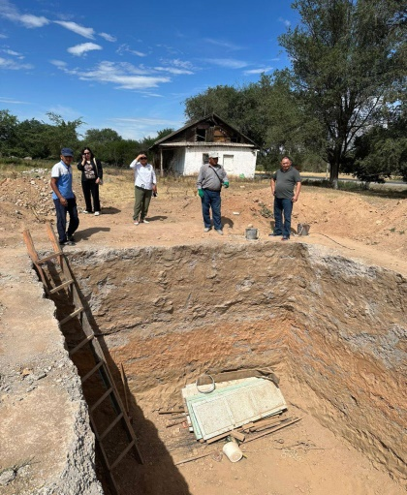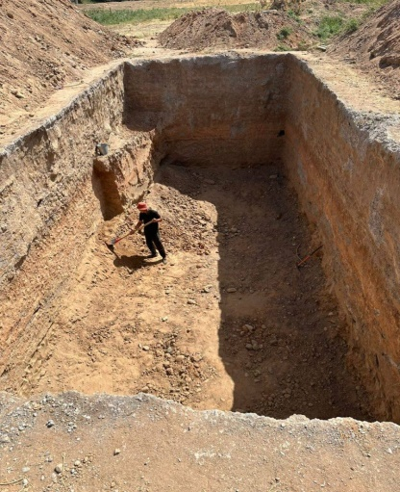
Photos 74, 75. Excavation site on the territory of Tokmok SSI in August 2023
- Violation of air and heat regime norms in social institutions
In the period from 17 to 19 January 2023, the National Center visited 14 social stationary institutions located in Chui Province in order to check the temperature regime.
Due to the power outage, in many institutions, low air temperature was recorded in the premises. Only cold water was available in the sanitary facilities. In some institutions there was a problem with food cooking for the persons under care due to power outages.
According to sanitary and epidemiological requirements, the temperature in the premises should be from +18 to +24⁰C. However, in five out of 14 institutions the average temperature at the time of the inspection was 13-14⁰C. As a result, unscheduled inspections were conducted by the Center for State Sanitary and Epidemiological Surveillance (CSES) of Bishkek city.
According to the results of an unscheduled inspection by the Center for State Sanitary and Epidemiological Surveillance of 19 January 2023, the air temperature in the classrooms of the Specialized Boarding School for Hearing Impaired and Deaf Children ranged from +8 to +12⁰C, and during the power outage - from +5 to +8⁰C. Due to the recommendations of the National Center and the CSES, this facility was switched to online instruction on 20 January 2023 until the air and heat conditions in the rooms normalize.
- Jayil Psychoneurological SSI
On 25 February 2023, during the visit to the institution, the overcrowded condition of ward No. 2 for critically ill patients was revealed. Thus, there were 90 people in the building, while the building is designed for 70 beds. Violations of sanitary and hygienic norms were recorded.
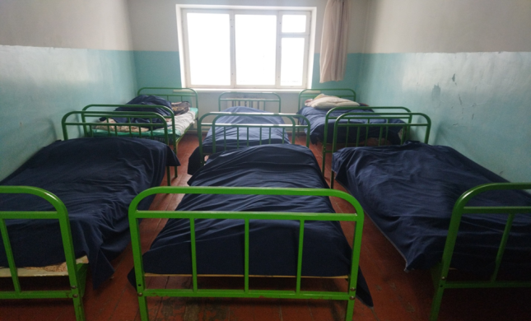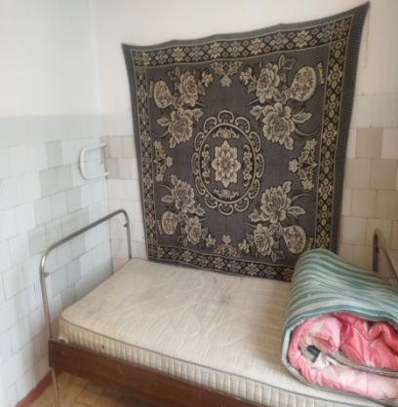
Photo 76. Overcrowded living rooms Photo 77. Room of the isolation ward after renovation

THE RIGHT TO FREEDOM FROM TORTURE AND ILL-TREATMENT IN CHILDREN'S BOARDING INSTITUTIONS
In 2023, the National Center submitted an alternative report to the UN Committee on the Rights of the Child (hereinafter referred to as the Committee).
- In its previous Concluding Observations, the Committee recommended to Kyrgyzstan to ensure that all children born on its territory are registered and provided with standardized birth certificates immediately after birth without undue delay, irrespective of whether their parents have identity documents or residence registration. The Committee also recommended that the birth registration procedure be simplified and that no unlawful requirements be imposed in the process of restoring birth certificates ( Paragraph 25).
Despite the fact that the Ministry of Digital Development of the Kyrgyz Republic has conducted and strengthened work on registration and documentation of convicts, during the National Center's visit to the women's correctional colony No. 2 in April 2023, convict I. reported that she had a two-year-old child who still had no documents. The convict does not have a passport, as a result of which she cannot obtain a birth certificate for the child and does not receive allowance for the child.
- The Committee recommended to Kyrgyzstan to ensure that children in alternative care institutions are provided with quality nutrition adequate for their age and that this is adequately monitored (Paragraph 42 (с)).
During a visit in April 2023 to the Kara-Suu specialized boarding kindergarten for deaf children, expired food products were found. At the same time, it was revealed that only 28 soms were allocated for food for one child in accordance with the Decree of the Government of the Kyrgyz Republic “On monetary norms of nutrition in social sphere institutions” dated 15 January 2008, No. 7.
In accordance with the Resolution of the Cabinet of Ministers of the Kyrgyz Republic “On Amendments to the Resolution of the Government of the Kyrgyz Republic “On monetary norms of nutrition in social sphere institutions dated 15 January 2008 No. 7” of 29 July 2022 No. 405, changes were made to the calculated norms of nutrition - the amount was increased to 220 soms (Paragraph 13). However, this resolution refers to children in social stationary institutions of the Ministry of Labor, Social Welfare and Migration, and does not affect the funding of meals for children in boarding institutions under the Ministry of Education and Science.
According to the information of the Ministry of Finance and the Ministry of Education and Science it is noted that during the discussion of the country's budget for 2024, as well as the budget plan for 2025 and 2026, the issue of increasing the food ration will be considered taking into account the real financial possibilities.
On 6 April 2023, during the preventive visit of the National Center staff to the Panfilov boarding school named after K. Tilebaliev, expired medicines were found in the dental office. However, in 2022-2023, 5,707,000 soms were allocated from the State budget for medicines and medical care for children in children's institutions of the Ministry of Education and Science.
The National Center also draws attention to the recommendation to Kyrgyzstan by the UN Committee on the Rights of the Child following consideration of the combined fifth and sixth periodic reports to ensure that the national preventive mechanism has the capacity and sufficient resources to monitor all places of detention and alternative care facilities.

THE RESULTS OF A SURVEY OF SERVICEMEN PERFORMING COMPULSORY MILITARY SERVICE IN MILITARY UNITS WITH REGARD TO THE OBSERVANCE OF THE RIGHT TO FREEDOM FROM TORTURE AND ILL-TREATMENT
In 2022-2023, the National Center, jointly with the Geneva Center for Security Sector Governance (DCAF, www.dcaf.ch), conducted a survey of conscript soldiers on the observance of their civil, social and economic rights. This study was conducted in the Kyrgyz Republic for the first time. The results of the first stage of the survey were reflected in the NCPT report for 2022. The second stage was conducted in June-July 2023.
A total of 170 conscripts of military units located in Osh city (Osh Province), Balykchi and Karakol cities (Issyk-Kul Province), Koy-Tash village (Chui Province), Kok-Oi village (Talas Province), Muras and Bujum villages (Batken Province) participated in the survey.
The anonymous survey covered the issues of observance of the right to freedom from torture and ill-treatment, freedom from forced labor, access to information, provision of medical services, adequate food, necessary housing and sanitary and hygienic conditions.
According to the survey results:
- 8% of respondents indicated that they or other soldiers had experienced torture or ill-treatment.
- 87% indicated that they had been informed about complaint procedures in cases of torture, inhuman or degrading treatment. However, 25% of soldiers reported that they would not have filed a complaint if such cases had occurred because of a lack of confidence that an investigation would be initiated, conducted impartially and promptly.
- 24% of conscripts were not confident that they would be protected from negative consequences after filing a complaint and that officers found guilty would be punished (36%).
- In case of ill-treatment, conscripts reported that they do not expect to receive psychological (36%) or medical support (21%).
- Ethnicity, religion, language, place of residence (city, village) were not considered by soldiers as elements leading to torture and ill-treatment.
- According to the soldiers, age (8.93%) and position in the military hierarchy (8.43%) are the main factors contributing to ill-treatment.
- The results of the survey have been submitted to the relevant state authorities.
The National Center is planning to conduct the second stage of a comprehensive study of the situation with respect for the rights of conscripts in the Kyrgyz Republic.

SECTION 3. RESULTS OF REVIEW OF Allegations of torture, ill-treatment and statements of the NATIONAL CENTER in 2023
In total, in 2023, the National Center received 119 statements with complaints of torture, ill-treatment and unsatisfactory conditions of detention.
- use of torture - 59
- ill-treatment - 38
- Inhuman, degrading conditions of detention – 22

RESULTS OF THE REVIEW OF ALLEGATIONS OF TORTURE AND ILL-TREATMENT REPORTED TO THE NATIONAL CENTER IN 2023

- ALLEGATIONS OF TORTURE
The number of allegations of torture reported to the National Center in 2023 has slightly decreased compared to the data of 2021 and 2022. Nevertheless, it is clear that 59 allegations of torture per year (taking into account the percentage of latency of this crime) is a serious enough figure, indicating the systemic nature of torture, as well as a critical problem that needs to be addressed as soon as possible.

Figure 8: Trend in the number of allegations of torture reported to the National Center for the period from 2020 to 2023

Half of the total number of complaints received by the staff of the National Center are received directly from alleged victims of torture and ill-treatment during preventive visits to places of deprivation and restriction of liberty.

Figure 9: Source of information on torture
As in previous years, the majority of complainants reported torture by internal affairs officers (71%). 29% of the total number of complaints in 2023 were about torture by national security officers.

Figure 10. Number of allegations by institution against whose employees the National Center received a complaint of torture in 2023

The most common method of torture remains the infliction of physical suffering by beating with hands and feet (58%). One in six (13%) reported the use of a plastic bag or gas mask to suffocate during torture. Four complainants reported the use of a stun gun. Other methods of torture included putting a needle under the fingernails, threatening rape with a bottle, denial of food and water, dousing with cold water in winter, beating with the butt of an automatic rifle in the face and knocking out teeth. Psychological pressure in the form of humiliation and insults was also mentioned.

Figure 11. Methods of Torture

Figure 12. Purposes of torture

The following procedural decisions were taken as a result of the review of allegations of torture received by the National Center in 2023:
- The initiation of criminal proceedings was denied in 39 applications on the basis of Article 27 (P.1, Paragraph 2) of the Criminal Procedure Code, of which:
- District/city prosecutor's offices - 14,
- Military Prosecutor's Office - 13,
- SCNS - 9,
- Regional prosecutor's offices – 3.
- The district prosecutor's office discontinued the criminal case on the basis of Article 27(1)(13) of the Criminal Procedure Code due to mutual agreement during the investigation - 1.
- At the time of the drafting of the report, 19 applications were being investigated as part of pre-investigative proceedings and appropriate expert examinations had been ordered:
- District/city prosecutor's offices - 6,
- Military Prosecutor's Office - 3,
- SCNS – 10.
- ALLEGATIONS OF ILL-TREATMENT
In 2023, 38 people applied to the National Center with complaints of ill-treatment by employees of various ministries and agencies.
The main number of complaints of ill-treatment came from institutions under the jurisdiction of the Ministry of Internal Affairs - 47%, SIN officers - 37%, SCNS officers - 10%, Ministry of Health - 3% and judicial bodies - 3%.

Figure 13. Number of allegations of ill-treatment received by the National Center in 2023, by ministries and agencies

Figure 14. Number of allegations of ill-treatment received by the National Center in 2023, by province

Compared to the previous year, in 2023, the total number of complaints of ill-treatment decreased by 39% in Bishkek and Osh cities, and in Jalal-Abad and Issyk-Kul provinces. At the same time, the number increased in Naryn Province.
All allegations of ill-treatment were referred to the prosecutor's office, and the following decisions were made as a result of their consideration:
- The initiation of criminal proceedings was denied in 26 applications on the basis of Article 27 Part 1 Paragraph 2 of the Code of Criminal Procedure, of which:
- District/city prosecutor's offices - 11,
- SCNS - 4,
- Prosecutor's Office for Supervision of Compliance with Laws in Correctional Institutions and Bodies - 4,
- SIN, on the grounds of non-confirmation of the arguments stated in the application - 3,
- SIN, on the basis of termination of the case due to receipt of a counter-application - 2,
- by the Investigation Service of the Ministry of Internal Affairs - 2.
- In one application, the SIN reported that work had been carried out to improve the conditions of detention of persons under investigation.
- The prosecutor's office issued an instruction to the staff of the SCNS pre-trial detention facility to strictly comply with the requirements of the Internal Regulations - 1.
- At the time of writing the report, 10 applications were being investigated as part of pre-investigation proceedings:
- District/city prosecutor's offices - 6,
- Military Prosecutor's Office - 2,
- SCNS - 2.

RESULTS OF REVIEW OF STAEMENTS BY THE NATIONAL CENTER ON VIOLATIONS REVEALED IN 2023
The National Center prepares statements on violations of the norms of national legislation, standards of humane treatment and conditions of detention in closed institutions revealed during preventive visits and sends them to the relevant state authorities for verification, elimination of violations and bringing the perpetrators to justice.
In 2023, the National Center prepared 142 statements.

Figure 15. Number of statements of the National Center prepared for the period 2021-2023

Types of violations for which statements were prepared:
- failure to notify the National Center of the death of a person held in a closed institution - 1,
- unlawful court rulings on the detention of a person in a TDF - 3,
- exceeding the period of detention in a TDF for more than 10 days - 3,
- failure to register in the Journal of persons delivered to TDFs - 5,
- absence of a detention report in the case file - 1,
- refusal to provide a copy of the detention report - 2,
- placement of TDF cells in the basement of the IAD building under construction - 1,
- violation of the requirements for filling out the Medical Examination Form No. 33-u when a person is brought to a TDF - 12,
- unsatisfactory conditions of detention in administrative detention cells at IAD front offices - 8,
- overcrowded cells in PTDCs of the SIN - 1,
- unsatisfactory conditions of detention in places of deprivation and restriction of liberty - 75,
- ill-treatment - 6,
- violation of sanitary norms in places of deprivation and restriction of liberty - 10,
- violation of storage conditions for medications - 3,
- expired medications in the first aid kit - 6.

Diagram 16. State bodies, local self-governance bodies, to which statements were sent

The following decisions were made based on the results of consideration of the above-mentioned statements:
- the prosecutor's office issued instructions to eliminate violations of the law - 13,
- violations were not eliminated due to objective circumstances - 8,
- violations were eliminated by the management of institutions - 79,
- no violations were found as a result of the inspection - 1,
- violations were taken into account - 8,
- based on the results of the inspection, 2 employees of the narcology department of the Center of General Medical Practice were dismissed due to gross violations of their labor duties,
- 42 employees received a disciplinary action in the form of a “reprimand”,
- Disciplinary action in the form of a “severe reprimand” was issued to 2 employees,
- Disciplinary action in the form of a “warning” was issued to 17 staff members,
- Disciplinary action in the form of a “reprimand” was issued to 7 staff members,
- 1 staff member was indicated to be unfit for his/her position,
- two employees were fined for violation of sanitary norms,
- 1 case was registered in the IR UCR,
- 1 criminal case was initiated,
- criminal proceedings were rejected - 5.
It should be noted that from year to year the authorized state bodies react more responsibly to the revealed violations. Thus, as a result of consideration of 142 statements of the National Center, appropriate measures have been taken in 85%. Measures have not been taken for 22 statements due to various reasons.

SECTION 4. SYSTEMIC CAUSES OF TORTURE
This section is based on the analysis of compliance of legislation and practice with international standards and recommendations of international treaty bodies in the field of combating torture and ill-treatment.
The Kyrgyz Republic, acting as a sovereign state and a full-fledged participant in international relations, has undertaken obligations on the absolute prohibition of torture and actively implements a policy of combating this phenomenon at the national level. Kyrgyzstan actively participates in international human rights procedures through the UN treaty bodies, including the procedures of the International Covenant on Civil and Political Rights (hereinafter - ICCPR), the Convention against Torture, the Optional Protocol to this Convention, as well as other international documents.
The revealed systemic problems related to combating torture in the country that require special attention are presented below. For their analysis, previous recommendations of international treaty bodies, including the UN Human Rights Committee, the UN Committee against Torture, the Subcommittee on Prevention of Torture and relevant recognized standards have been considered.

- DEFINITION OF THE TERM “TORTURE” AND ITS CLASSIFICATION AS A CRIMINAL OFFENCE
Article 4 of the UN Convention against Torture stipulates the obligation of all states to deal with acts of torture in accordance with its criminal law, including attempts to torture and participation or complicity in torture.
The Convention against Torture defines the term “torture” as “The Convention against Torture defines the term “torture” as “any act by which severe pain or suffering, whether physical or mental, is intentionally inflicted on a person for such purposes as obtaining from him or a third person information or a confession, punishing him for an act he or a third person has committed or is suspected of having committed, or intimidating or coercing him or a third person, or for any reason based on discrimination of any kind, when such pain or suffering is inflicted by or at the instigation of or with the consent or acquiescence of a public official or other person acting in an official capacity”.
In Paragraph 9 of the Concluding Observations, the UN Committee against Torture recommended that the Kyrgyz Republic harmonize the content of the article “torture” of the Criminal Code with all the elements contained in Article 1 of the Convention against Torture.
In view of the fact that Article 137 of the Criminal Code does not fully reflect the full essence of the inevitability of punishment for torture, the National Center recommends:
- Bring the content of the article “Torture” in line with the Convention.

- CRIMINALIZATION OF CRUEL, INHUMAN OR DEGRADING TREATMENT OR PUNISHMENT
According to Article 16 of the Convention against Torture, “Each State Party shall undertake to prevent in any territory under its jurisdiction other acts of cruel, inhuman or degrading treatment or punishment which do not amount to torture as defined in article I, when such acts are committed by or at the instigation of or with the consent or acquiescence of a public official or other person acting in an official capacity”.
In 2022, the National Center received 62 allegations of cruel, inhuman or degrading treatment or punishment. The number of such allegations in 2023 was 59.
Although the Constitution expressly prohibits cruel, inhuman or degrading treatment or punishment (“No one shall be subjected to torture or other inhuman, cruel or degrading treatment or punishment”), the Criminal Code punishes cruel treatment or humiliation of a person's dignity only under Article 128 of the Criminal Code “Leading to suicide”.
Therefore, the National Center recommends:
- Criminalize the use of cruel, inhuman or degrading treatment or punishment in legislation.

- FUNDAMENTAL LEGAL SAFEGUARDS AGAINST TORTURE
Essential legal safeguards are provided to all detainees without exception. When it comes to the rights of a person detained on suspicion of committing a crime, we discuss the right of every person to freedom and personal integrity without any discrimination, as well as the right to protection from torture and other forms of humiliating treatment during detention and at all other stages of investigation. Often, detainees are taken to and kept in IAD buildings without proper registration and without a certain status. Citizens are called “for a conversation” or “as a witness”, while in fact they remain in the status of a detainee. However, due to the lack of the detainee status, they are not provided with the relevant rights. This allows police officers to keep a person without any procedural guarantees in the state of “incommunicado” for a long period of time. It is this period that is used by unscrupulous police officers to extort bribes, torture and other human rights violations.
According to the National Center, 90% of all persons who reported torture were subjected to torture by police officers in the first hours of detention. Preliminary analysis of cases in the proceedings of the Association for the Protection of Human Rights in Criminal Proceedings “Article-9” has shown that in each case the detention is accompanied by violations of the safeguards provided by law, including: failure to provide timely access to defense; exceeding the time limits of detention; failure to respect the right to a telephone call and the right to be informed.
According to the Constitution of the Kyrgyz Republic, “Every detained person shall be promptly informed of the reasons for detention and his or her rights shall be explained. From the moment of detention, a person shall be provided with security, given the opportunity to defend himself/herself personally, to use qualified legal assistance of a lawyer, as well as the right to medical examination and assistance of a doctor”. However, according to the study, the grounds for detention were explained only in 13% of cases, and in 87% of cases this was not done. The rights of the detainee were not explained in 80% of cases.
The detainees were registered in the register of IA bodies only in 16% of cases, and in 84% of cases they were not registered. It should be noted that according to the order of the Ministry of Internal Affairs of the Kyrgyz Republic dated 31.03.2015 “On the organization and enforcement of access control on the territory and premises of administrative buildings of internal affairs bodies, all persons brought to the internal affairs body must be registered according to the appropriate procedure.
Also, according to the conducted research, 90% of medical examination forms for detainees, filled out by medical workers before taking the person to the isolation ward, do not comply with the approved Instruction. Medical examination is not carried out every time a detainee is brought to a TDF, medical assistance in isolation facilities is limited only by the availability of a medical kit and calls for “emergency medical aid”.
If a detainee complains of torture and ill-treatment, he or she is practically deprived of legal safeguards for a timely medical examination and an effective mechanism to investigate his or her complaint. The preliminary verification stage actually deprives a torture victim of procedural guarantees provided for by national legislation and international norms. Preliminary verification of allegations of torture is conducted for an unreasonably long time, forensic examinations are scheduled untimely, when signs of bodily injuries have already disappeared, resulting in the termination of cases. The cycle of “verification-rejection-cancellation-verification” can last for a long time, which in many cases results in irretrievable loss of evidence.
Taking into account the above, and the recommendation of the UN Committee against Torture (Paragraph 15), where the Committee recommends to Kyrgyzstan to “ensure that all arrested or detained persons, including minors, are provided in practice with all fundamental legal safeguards against torture from the very outset of their deprivation of liberty, including the right to prompt access to a lawyer or, if necessary, to free legal aid, especially during the investigation and interrogation stages, the right to request and promptly undergo a medical examination, and the right to have a medical examination:
b) Review the Criminal Procedure Code and ensure its full compliance with the ICCPR and international standards related to fair trial and administration of justice. In particular, consideration should be given to abolishing pre-trial inspection as a concept and practice that violates fair trial standards, as it bypasses the human rights safeguards that should be provided to victims of crime and suspects;
c) Ensure that all allegations of torture and ill-treatment are investigated promptly, impartially, thoroughly and effectively, that perpetrators are brought to justice and that victims are provided with full redress, including rehabilitation and adequate compensation;
Therefore, the National Center recommends:
- To make the necessary amendments to normative legal acts in order to ensure the stipulated safeguards against the use of torture.

- CREATION OF AN EFFECTIVE MECHANISM FOR MEDICAL DOCUMENTATION OF SIGNS OF TORTURE AND AN INDEPENDENT MECHANISM TO INVESTIGATE ALLEGATIONS OF TORTURE
According to the UN Convention against Torture, “Each State Party shall ensure that its competent authorities proceed to a prompt and impartial investigation, wherever there is reasonable ground to believe that an act of torture has been committed in any territory under its jurisdiction” (Article 12), “Each State Party shall ensure that any individual who alleges he has been subjected to torture in any territory under its jurisdiction has the right to complain to, and to have his case promptly and impartially examined by, its competent authorities. Steps shall be taken to ensure that the complainant and witnesses are protected against all ill-treatment or intimidation as a consequence of his complaint or any evidence given” (Article 13).
The principles of investigation of torture and ill-treatment recognized by the international community are set out in the second edition of the “Istanbul Protocol”, presented on 29 June 2023 in Geneva. It is a set of rules for lawyers and medical professionals to investigate and record facts of torture and ill-treatment. The new version of the document is the result of 23 years of work by 180 scientists from 51 countries.
The Convention against Torture provides three pillars in the fight against torture: the obligation of states to provide justice, prevention and redress for cases of torture. The duty to investigate is central to the implementation of all three pillars. Under international law, States must investigate allegations of torture promptly, impartially and effectively. The fundamental principles of any meaningful investigation of torture are: competence, impartiality, independence, adequate resources, promptness, effectiveness, thoroughness, consideration of gender, age, disability and similar recognized characteristics, participation of the victim and public scrutiny of the investigation.
Unfortunately, the investigation of torture in Kyrgyzstan is conducted ineffectively. If we take statistical data of the General Prosecutor's Office, annually, almost 90% of the received allegations of torture are denied initiating criminal proceedings. Thus, the number of allegations of torture decreases annually, not because torture is not used, but because the victims do not believe in the inevitability of punishment of the perpetrators.
The Human Rights Committee recommended to Kyrgyzstan:
- Ensure that all allegations of torture and ill-treatment are investigated promptly, impartially, thoroughly and effectively, that perpetrators are brought to justice and that victims are provided with full redress, including rehabilitation and adequate compensation (Paragraph 30 (c)).
In its Observations, the Committee against Torture recommended to Kyrgyzstan:
- Ensure prompt, independent, impartial and effective investigations into all allegations of torture and ill-treatment by law enforcement officials, including against lesbian, gay, bisexual and transgender persons, and ensure that perpetrators are brought to justice and that victims are adequately compensated and rehabilitated (Paragraph 25(a)).
Therefore, the National Center recommends:
- Bring the investigation procedure for all allegations of torture and ill-treatment in line with international standards.
- Implement the Istanbul Protocol standards for the investigation of torture and ill-treatment and the medical recording of bodily injuries and moral harm inflicted on torture victims.

- PAYMENT OF COMPENSATION TO VICTIMS OF TORTURE
According to Article 14 of the UN Convention against Torture, “Each State Party shall ensure in its legal system that the victim of an act of torture obtains redress and has an enforceable right to fair and adequate compensation, including the means for as full rehabilitation as possible. In the event of the death of the victim as a result of an act of torture, his dependents shall be entitled to compensation”.
Kyrgyzstan does not fully fulfill its obligations to restore the rights of torture victims based on the decisions of the UN Human Rights Committee.
To date, the Committee has issued decisions recognizing human rights violations by the Kyrgyz Republic in more than 40 individual reports. In 34 reports, which is the absolute majority (86%), the Committee recognized a violation of Article 7 of the ICCPR (right to freedom from torture).
In seven of the 34 individual reports alleging death by torture by officers, the Committee found a violation by the State of Article 6 (right to life), in conjunction with Article 7 (right to be free from torture) of the ICCPR. In each decision on these seven reports, the Committee stated that the State was under an obligation to conduct a prompt, effective, thorough, independent, impartial and transparent investigation into the torture and the circumstances of the death, to prosecute with punishment, and to pay proportionate compensation to the representatives of the deceased. Only three of the Committee's decisions had resulted in compensation being paid to the representatives of victims who had died as a result of torture. The proportionality and adequacy of the payments of 200,000 and 300,000 soms for the death of a person as a result of torture in a closed institution is highly questionable. In two cases (F. Fiziev, B. Akunov), representatives of torture victims were refused by the Supreme Court of the Kyrgyz Republic to satisfy the request to reopen the case for investigation of death as a result of torture due to newly discovered circumstances. No compensation was paid.
In the Concluding Observations on the consideration of the Third Periodic Report of Kyrgyzstan in 2021, the UN Committee against Torture once again expressed regret that no mechanism for redress for acts of torture and ill-treatment had been established and that, in practice, victims of torture did not receive fair and adequate redress, compensation and rehabilitation as a result of acts of torture and ill-treatment (Paragraphs 2, 10-16). In this regard, the Committee recommended that the Kyrgyz Republic collect and provide the Committee with information on measures of redress and compensation, including means of rehabilitation imposed by orders of courts or other bodies and actually provided to victims of torture or ill-treatment, including amounts paid.
In addition, the Concluding Observations of the UN Human Rights Committee recommended revising the legislation to allow victims of torture to bring civil claims for redress even if a criminal case is pending or has not resulted in a conviction, in line with the Committee's General Comment No. 3 (2012).
The Resolution of the Jogorku Kenesh of the Kyrgyz Republic No. 318-VII dated 16 June 2022 “On the annual report of the National Center of the Kyrgyz Republic on Prevention of Torture and Other Cruel, Inhuman or Degrading Treatment or Punishment for 2021” The Cabinet of Ministers of the Kyrgyz Republic was recommended: “In order to fulfill international obligations to ensure the right to humane detention and restoration of violated rights of victims of torture - to introduce, in accordance with the established procedure, draft laws to regulate the mechanisms of compensation for victims of torture and ill-treatment”. However, this recommendation of the National Center, enshrined in an Act of the legislative body of the country, has not been implemented to date.
In order to fulfill the international obligations of the Kyrgyz Republic in terms of compliance with the principle of inevitability of punishment for torture and restoration of violated rights of victims of torture, the National Center recommends:
- As a matter of urgency, develop and adopt a normative act regulating the process of calculating material and moral damages to be paid as compensation to a victim of torture or their representatives.
- Ensure that the monetary compensation awarded by the court for moral harm inflicted on a victim of torture is proportionate and adequate.
- Ensure that compensation is paid to all victims of torture or their representatives for each decision of the UN Human Rights Committee where the Committee has recognized a violation of the ICCPR.
- Eliminate the practice of the Supreme Court of the Kyrgyz Republic refusing to grant requests to reopen a case due to newly discovered circumstances based on a decision of the UN Human Rights Committee.
- Eliminate the practice of the Ministry of Finance challenging court decisions on the recovery of monetary compensation from the state budget in favor of a victim of torture.
- Provide detailed information on compensation paid to victims of torture to the UN Committee against Torture and other relevant UN mechanisms.

- THE PRINCIPLE OF THE PROHIBITION OF EXTRADITION AND RETURN TO A COUNTRY WHERE THERE IS A RISK OF TORTURE AND ILL-TREATMENT
According to Article 3 of the UN Convention against Torture, “1. No State Party shall expel, return (“refouler”) or extradite a person to another State where there are substantial grounds for believing that he would be in danger of being subjected to torture. 2. For the purpose of determining whether there are such grounds, the competent authorities shall take into account all relevant considerations including, where applicable, the existence in the State concerned of a consistent pattern of gross, flagrant or mass violations of human rights”.
According to the comments of the UN Country Team in Kyrgyzstan on extradition, the necessary additions to the provisions of the Criminal Procedure Code have been developed to ensure in practice the prohibition of refoulement, return and extradition of a person to a country where there is a real threat of torture against him/her.
These amendments to the criminal legislation of the countries have also been developed in response to the Comments of the UN Human Rights Committee (“The State party should strictly adhere to the absolute prohibition of refoulement under Articles 6 and 7 of the Covenant and exercise the utmost caution in assessing diplomatic assurances; ensure that there is adequate, effective and independent monitoring of the situation of persons transferred under diplomatic assurances after their extradition; and not rely on such assurances when the State party is unable to effectively monitor the treatment of such persons after their extradition, refoulement, transfer or return to their country of origin”), as well as the Concluding Observations on Kyrgyzstan of the UN Committee against Torture (“The State party should ensure that, in practice, no one can be deported, returned or extradited to another State where there are substantial grounds for believing that he or she would personally face a foreseeable risk of being subjected to torture or ill-treatment”).
Therefore, the National Center recommends:
- To bring the country's criminal legislation into full compliance with international standards on the prohibition of extradition of a person in cases of threat of torture and ill-treatment (according to the package of legislative initiatives developed by the UN Country Team in the Kyrgyz Republic).

- EFFECTIVENESS OF THE NATIONAL PREVENTIVE MECHANISM
Since 2012, the National Center for the Prevention of Torture has been functioning as a national preventive mechanism. In 2022, according to the Note Verbale of the Office of the UN High Commissioner for Human Rights, for the first time in history, after gaining independence, the Kyrgyz Republic was included in the top ten countries in the world with the best system of national preventive mechanisms. Despite this, the state authorities are still considering the issue of liquidating the National Center and transferring its functions to the Akyikatchy Institute (Ombudsman), which would entail the risk of destroying a fully functioning mechanism for the protection of human rights to freedom from torture in the country.
In its Concluding Observations, the UN Human Rights Committee noted, “While noting the explanation provided by the State party on its decision to merge the National Center for the Prevention of Torture with the Office of the Ombudsman, the Committee remains concerned that the National Center for the Prevention of Torture is not sufficiently funded to carry out its mandate effectively and independently”. In Paragraph 30, the Committee recommends that Kyrgyzstan provide the National Center with the necessary financial resources to carry out its mandate effectively and independently, including by ensuring unimpeded access of its staff to all places of deprivation of liberty and introducing administrative and criminal liability for unlawful interference in the work of the National Center.
The Concluding Observations of the UN Committee against Torture also contain recommendations to ensure the functioning of the NCPT. Thus, it is noted that the State should:
“a) Reintroduce article 146-2 of the Criminal Code and ensure that any obstruction or interference in the work of the National Centre for the Prevention of Torture is effectively investigated and the perpetrators brought to justice;
b) Provide the National Center with the necessary financial, human and material resources to carry out its mandate effectively throughout the country, ensuring its unhindered access to all places of deprivation of liberty, as well as the possibility of having confidential meetings with prisoners”.
Therefore, the National Center recommends:
- Reintroduce criminalization of obstruction and interference in the activities of the National Center for the Prevention of Torture.

- CONDITIONS OF DETENTION IN PLACES OF DEPRIVATION AND RESTRICTION OF LIBERTY
The UN Human Rights Committee and the UN Committee against Torture, in their Conclusions, have commended the State for the measures taken to renovate some places of detention and to build additional facilities for prisoners serving life sentences. However, the Committee remains concerned about reports of inadequate and poor conditions of detention, including overcrowding of facilities. Of particular concern to the Committee were the appalling conditions of detention for women and the lack of adequate medical care, including for pregnant women and mothers with children. The Committee is also concerned about reports of very poor conditions in psychiatric hospitals, social care homes and children's boarding schools.
According to Paragraph 36 of the Concluding Recommendations of the Human Rights Committee, Kyrgyzstan should:
“b) Strengthen its efforts to improve conditions of detention, including in psychiatric institutions, and ensure respect for the dignity of persons deprived of their liberty, in accordance with Article 10 of the ICCPR and the “Nelson Mandela Rules”, by allocating sufficient financial and human resources;
c) Ensure that adequate medical care is provided to all detainees in a timely manner and that the necessary specialized treatment is provided. If the required in-patient treatment is not available in the penitentiary institution, the use of public health facilities and alternative non-custodial measures should be considered”.
In Paragraph 23 of the Concluding Observations, the Committee against Torture urges Kyrgyzstan to:
«a) Intensify efforts to improve detention conditions and reduce the overcrowding of penitentiary institutions, including through the application of non-custodial measures. Prisoners should be provided with adequate material and hygienic conditions, including sufficient natural and artificial light; adequate sewage and sanitation facilities, including toilets and showers; heating in prison cells; adequate ventilation; adequate quality and quantity of food, bedding, blankets and personal hygiene items; medical care; opportunities for outdoor exercise and family visits.;
b) Ensure a sufficient number of doctors and psychiatrists in all places of deprivation of liberty;
c) Ensure adequate conditions and a sufficient number of female staff in places of deprivation of liberty for women;
d) Improve conditions in psychiatric hospitals, social care institutions and children's institutions”.
Therefore, the National Center recommends:
- Bring national standards of detention in places of deprivation and restriction of liberty in line with adopted international standards.

CONCLUSIONS AND RECOMMENDATIONS
Analysis of the National Center's activities makes it possible to make the following conclusions:
- According to the “Torture Index” study”, the number of persons subjected to torture in places of deprivation and restriction of liberty has decreased one and a half times over the past five years. Whereas previously every third person reported torture, nowadays it is every fifth. These statistics, however, testify to the continuing practice of torture in the country and its systemic nature.
- One of the main factors encouraging the use of torture against persons held in places of deprivation and restriction of liberty is impunity. Over the past ten years, not a single official has been convicted for the use of torture.
- The level of torture is directly related to the number of prison population in the country; according to the criminal procedure legislation, detention is the strictest measure and should be carried out in exceptional cases. Despite the fact that the law provides for five types of preventive measures not related to detention, according to judicial statistics for the year 2023, in 95% of all preventive measure rulings, the courts have decided on detention.
- Payments of compensation by the state to victims of torture, based on the decisions of the UN Human Rights Committee, are rare. Moreover, the amount of compensation paid is inadequate to the harm suffered.
- Despite repeated demands to prohibit the placement of cells in the basement and semi-basement premises of TDF and PTDC buildings, their use continues. Construction of new facilities in the basements of internal affairs bodies also continues.
- Medical support in penal institutions does not meet the criteria of timeliness and efficiency. The process of transferring the medical service of the SIN to the Ministry of Health is currently suspended.
- To date, convicts with terminal illnesses die within the walls of penitentiary institutions, without palliative care and appropriate treatment. The existing resolutions of the Government of the Kyrgyz Republic on the approval of the “List of serious diseases that prevent the detention of suspects and accused persons” and the “List of diseases that are grounds for exemption from further serving of sentence” are used only in rare cases.
- The State does not fully fulfill its obligations to guarantee the safety of persons in custody and in places of deprivation of liberty. The deaths of prisoners are caused not only by the unscrupulous performance of their functional duties by individual staff members, but also, in general, by the ineffectiveness of the system for preventing murders and suicides in closed institutions.
Based on the generalization of practice and analysis of the implementation of the National Center's recommendations for previous years, the following recommendations are provided in order to eradicate the systemic causes of torture and ill-treatment in places of deprivation and restriction of liberty.
TO THE JOGORKU KENESH OF THE KYRGYZ REPUBLIC:
- Introduce a caveat in the Criminal Procedure Code that international legislation is an integral part of the law and is directly applicable.
- Bring the article “Torture” of the Criminal Code in line with all the elements contained in Article 1 of the UN Convention against Torture. In particular, to add the words “other persons acting in an official capacity” to the range of subjects of the “torture” offense specified in Article 137.
- Amend the Criminal Code in terms of responsibility and punishment for “ill-treatment”.
- Amend the Criminal Procedure Code to state that when a suspect reports that he or she has been subjected to torture or other unlawful acts or shows signs of violence, the investigating judge must instruct the supervising prosecutor to immediately verify these facts.
- Establish an independent body to investigate torture, possibly through the creation of an appropriate structural unit within the General Prosecutor's Office.
- Amend Article 494 of the Criminal Procedure Code in the part of the list of “Categories of persons subject to special procedures in criminal cases” to include Paragraph 11: “members of the Coordinating Council, employees of the National Center”.
- Add to the Criminal Code an article establishing criminal liability for obstructing in any form the exercise of the powers by a Coordinating Council member or a National Center employee.

TO THE SUPREME COURT OF THE KYRGYZ REPUBLIC:
- Eliminate the practice of issuing court rulings on the selection of a preventive measure and extension of the period of detention of persons under investigation and arrest, with a direct reference to their detention in temporary detention centers of internal affairs bodies.
- Strengthen control over compliance with the law when the courts consider changing the type of correctional institution, and also when granting conditional early release from serving a sentence to seriously ill convicts.
- Develop a Supreme Court Plenum to summarize judicial practice on the consideration of criminal cases under article “Torture” of the Criminal Code.

TO THE GENERAL PROSECUTOR'S OFFICE OF THE KYRGYZ REPUBLIC:
  - Strengthen control over the implementation of minimum requirements for the verification of allegations of torture, including at the stage of preliminary verification of reports of crime, and the timing of the investigation. Establish a commission to check the quality of preliminary verification of allegations of torture, including independent experts.
  - Amend the Regulation on the Unified Crime Register and the Criminal Procedure Code to exclude the possibility of intra-agency write-off of cases registered in the Information Register.
  - Analyze the quality of forensic medical examinations, with the involvement of independent experts.
  - Develop a Guide to Investigation of Torture based on the second edition of the “Istanbul Protocol” with training for prosecutors with relevant qualifications.

TO THE MINISTRY OF INTERNAL AFFAIRS OF THE KYRGYZ REPUBLIC:
- Assess the actual condition of administrative cells, with the allocation of funds for their renovation and reconstruction, taking into account the requirements of the Resolution of the Cabinet of Ministers of the Kyrgyz Republic “On the order of functioning of places of arrest and requirements for detention of persons subjected to arrest” dated 7 February 2022 № 55.
- Eliminate the practice of placing detainees in a temporary detention facility without a medical examination form #003-u, approved by the Order of the Ministry of Health No. 190 dated 24 March 2020, prepared in accordance with the requirements.
- Prevent the placement of cells of temporary detention facilities in basements and semi-basements during the construction of new buildings of internal affairs bodies.

TO THE MINISTRY OF JUSTICE OF THE KYRGYZ REPUBLIC:
- Strengthen control over the timely submission of investigated and convicted persons whose diagnoses fall under the “List of serious diseases that prevent the detention of suspects and accused persons” approved by the Government of the Kyrgyz Republic on 20 June 2018 №296, as well as the “List of diseases that are grounds for submitting convicted persons for release from serving their sentence” approved by the Government of the Kyrgyz Republic on 29 November 2011 №745.
- Resume the work on the phased transfer of the medical service of the penitentiary system to the Ministry of Health.

TO THE SENTENCE EXECUTION SERVICE UNDER THE MINISTRY OF JUSTICE OF THE KYRGYZ REPUBLIC:
- Provide safeguards for the safety of life and health of persons in custody and in places of deprivation of liberty.
- Timely submit materials to the judicial authorities for consideration of the release of seriously ill persons from further serving the sentence of imprisonment, or release from custody in connection with the presence of serious illnesses that prevent arrest.
- Take measures to improve conditions of detention of prisoners, compliance with sanitary and hygienic norms, requirements for lighting, heating and ventilation of premises, involvement of prisoners in physical training and healthy lifestyle.
- Eliminate the practice of using basement and cellar premises for the purpose of placing cells for detention of persons under investigation and arrest in PTDC-1.

TO THE MINISTRY OF HEALTH OF THE KYRGYZ REPUBLIC:
- Ensure strict compliance with the requirements for the completion of Form No. 003-u, approved by Order No. 190 of the Ministry of Health dated 24 March 2020 of the Ministry of Internal Affairs, by medical personnel for the medical examination of a detained person upon placement in a temporary detention facility of an internal affairs body.
- Establish a department for the treatment of persons who have committed a crime and in respect of whom a court has ordered compulsory medical measures and a forensic psychiatric examination department in the Republican Psychiatric Hospital in Chym-Korgon village.

TO STATE BODIES IN CHARGE OF PLACES OF DEPRIVATION AND RESTRICTION OF LIBERTY:
      - Exclude any manifestations of obstruction of the National Center's activities.
      - Strengthen control over compliance with the requirements of Article 16 of the Law on the National Center regarding the implementation of recommendations of the Coordinating Council and reports of the National Center on facts of torture and ill-treatment, according to which state bodies and officials are obliged to inform the Coordinating Council about the measures taken within a month from the date of receiving the recommendations, and in cases where the National Center reveals facts of torture and other forms of ill-treatment - to provide information about the measures taken in relation to torture and other forms of ill-treatment within twenty-four hours.
      - Submit the drafts of normative legal acts concerning the rights and freedoms of persons deprived of liberty and restricted in liberty, the procedure and conditions of their detention, as well as the prevention of torture and ill-treatment to the National Center, in accordance with Article 29(2)(3) of the Law on the National Center.
      - Strengthen control over the implementation of Article 29(2)(4) of the Law on the National Center in terms of publishing the annual reports of the National Center on the official websites of state bodies.

FINANCIAL REPORT OF THE NATIONAL CENTER for 2023
Reporting period: from 1 January to 31 December 2023
Unit of measure: som
Indicators | Line item and element codes | Approved as estimated for the year | Adjusted based on reporting year's estimates | Cash expenses
EXPENSES |  | 0 | 0 | 0
Salary | 2111 | 9649800 | 19793800 | 19793798,98
Basic salary | 21111100 | 0 | 0 | 18087869,70
Overheads | 21111200 | 0 | 0 | 1705929,28
Contributions to the Social Fund | 2121 | 1445100 | 2751400 | 2751400
Insurance contributions to the Pension Fund | 21211100 | 0 | 0 | 2751400
Expenses for business trips | 2211 | 722700 | 951600 | 951599,8
Transportation expenses | 22111100 | 0 | 0 | 257137
Hotel expenses | 22111200 | 0 | 0 | 336705,60
Per diem expenses | 22111300 | 0 | 0 | 357757,20
Communication services | 2212 | 374000 | 374000 | 372000
Telephone and fax communication services | 22122100 | 0 | 0 | 30000
Cellular communication services | 22122200 | 0 | 0 | 179350
Courier services | 22122300 | 0 | 0 | 9200
Postal communication services | 22122400 | 0 | 0 | 24250
Other communication services | 22122900 | 0 | 0 | 129200
Rent | 2213 | 73000 | 73000 | 72700
Rent of buildings and premises | 22131100 | 0 | 0 | 72700
Transportation services | 2214 | 205000 | 281000 | 233698,88
Gasoline, diesel and other fuel | 22141100 | 0 | 0 | 114196,88
Purchase of spare parts | 22141200 | 0 | 0 | 119502
Purchase of other goods and services | 2215 | 329500 | 299500 | 274349,82
Information technology services | 22151400 | 0 | 0 | 119623
Public servant training expenses | 22153100 | 0 | 0 | 6200
Representation expenses | 22154100 | 0 | 0 | 33229
Expenses for production of letterheads, badges | 22154200 | 0 | 0 | 68242
Provision of information & communication services | 22154300 | 0 | 0 | 7055,82
Other expenses related to payment for other services | 22154900 | 0 | 0 | 40000
Acquisition of items and materials for current operating purposes | 2222 | 91800 | 91800 | 89065
Acquisition of equipment and materials | 22221100 | 0 | 0 | 11500
Other purchases of supplies and materials | 22221200 | 0 | 0 | 77565
Utilities | 2231 | 608000 | 979900 | 979900
Payment for water | 22311100 | 0 | 0 | 191056
Payment for electricity | 22311200 | 0 | 0 | 390000,78
Payment for heating energy | 22311300 | 0 | 0 | 398843,22
Machinery and equipment | 3112 | 653200 | 653200 | 635440
Purchase of furniture | 31123210 | 0 | 0 | 201745
Purchase of office equipment | 31123220 | 0 | 0 | 102000
Acquisition of computer equipment | 31123230 | 0 | 0 | 331695
TOTAL current expenses |  | 14152100 | 26249200 | 26153952,48
 |  | 0 | 0 | 0
Total expenses |  | 14152100 | 26249200 | 26153952,48

Resolutions of the Jogorku Kenesh of the Kyrgyz Republic No. 566-VI dated 19 May 2016, No. 2350-VI dated 11 April 2018, No. 2670-VI dated 25 October 2018, No. 3245-VI dated 18 September 2019, No. 308-VII of 16 June 2022, No. 309-VII of 16 June 2022, No. 318-VII of 16 June 2022, No. 1102-VII of 19 April 2023.
Letter of the Corrections Service under the Ministry of Justice of the Kyrgyz Republic dated 19 May 2023 No. 100/02-750.
The first phase of the special study was conducted jointly with the Coalition against Torture in Kyrgyzstan in 2022.
Available at https://npm.kg/ru/atlas/.
Detailed information is provided in Section 2.4 of this report.
https://npm.kg/wp-content/uploads/2023/04/Opros-soldat-srochnoi-voennoi-sluzhby-2022__.pdf.
https://npm.kg/wp-content/uploads/2017/03/Voprosy-obespecheniya-prav-lits-s-tyazhelymi-zabolevaniyami-soderzhashhihsya-v-uchrezhdeniyah-v-SIN-pri-Ministerstve-yustitsii-Kyrgyzskoj-Respubliki.pdf.
https://npm.kg/wp-content/uploads/2023/04/polisi-1__10.04.23-g.pdf.
https://npm.kg/wp-content/uploads/2023/06/polisi-2_stambulskij-protokol.pdf.
https://npm.kg/wp-content/uploads/2023/05/Problemy-s-kotorymi-stalkivayutsya-zhenshhiny-v-ugolovnom-protsesse-1.pdf.
https://npm.kg/wp-content/uploads/2023/05/polisi-5-Narushenie-srokov-soderzhaniya-v-IVS.pdf.
https://npm.kg/wp-content/uploads/2023/06/Polisi-8-Vozmeshhenie-vreda___.pdf.
https://npm.kg/ru/video/.
https://npm.kg/ru/video/i-dolshe-veka-dlitsya-den/.
https://npm.kg/ru/video/.
https://npm.kg/ru/video/pravonarushenie-i-nakazanie/.
https://npm.kg/ru/video/beznakazannost-i-krugovaya-poruka-pytki-prodolzhayutsya/.
https://www.facebook.com/npm.KG/?locale=ru_RU.
Special study on the Torture Index. 2022. https://npm.kg/ru/indeks-praktiki-primeneniya-pytok/.
http://birduino.kg/pressaru/otchet-bdk-po-delam-po-pyitkam-rekomendaczii.
Criminal Code of the Kyrgyz Republic. Article 1.
Letter of the National Center dated 24.04.2023 No. 13-20/144.
Letter of the National Center dated 26.04.2023 No. 13-20/206.
Letter of the General Prosecutor's Office of the Kyrgyz Republic dated May 23, 2023 №08-04
Code of the Kyrgyz Republic "On Offences". Article 33.
Ibid. Article 526 Part 2.
Letter of the Operational Management Center of the Public Security Service of MIA of KR dated 23.05.2022 #11-1/241.
Letter of the Supreme Court of the Kyrgyz Republic dated 28.12.2023 .No. 01-22/2988.
Letter of the National Center dated 29.04.2023 .No. 15-20/20.
Letter of the National Center dated 06.07.2023 No. 18-20-160.
Letter of the National Center of the Kyrgyz Republic for the Prevention of Torture dated 06.09.2023 #13-20/183.
Letter of the Sentence Execution Service under the Ministry of Justice of the Kyrgyz Republic dated 26.09.2023 .#100/02-1687.
Criminal Procedure Code of the Kyrgyz Republic. Article 104.
Letter of the Supreme Court of the Kyrgyz Republic dated 28.12.2023 .No. 01-22/2988.
Response of the General Prosecutor's Office of the Kyrgyz Republic from dated 10.01.2024 №08-04 to the request of the National Center.
Response of the Supreme Court of the Kyrgyz Republic dated 28.12.2023 №01-22/2988 to the request of the National Center.
Letter of the National Center to the SIN under the Ministry of Justice of the Kyrgyz Republic dated 25.05.2022 №13-20/255.
Letter from the National Center to the Head of Institution #27 of the SIN under the Ministry of Justice of the Kyrgyz Republic dated 25.05.2022 #13-20/254.
Letter No. 100/03-1241 dated 26.07.2022 from the Penitentiary Service.
Letter of the National Center dated 21.02.2023 No. 13-20/54.
Letter of the National Center dated 24.04.2023 No. 13-20/119.
Letter of the National Center to the Ministry of Health of the Kyrgyz Republic dated 24.05.2023 .#17-20/42.
At the time of writing, no response had been provided.
Data by the Ministry of Labor, Social Welfare and Migration of the Kyrgyz Republic dated 9 January 2024.
Letter to the Chui Province Prosecutor's Office dated 09.08.2023 No. 13-20/161.
Available at https://tbinternet.ohchr.org/_layouts/15/treatybodyexternal/Download.aspx?symbolno=CRC%2FC%2FKGZ%2FCO%2F5-6&Lang=ru
Letter of the Ministry of Finance of the Kyrgyz Republic dated 13.10.2023 #13-1/12848.
Letter of the Ministry of Education and Science of the Kyrgyz Republic dated 28.09.2023 №04-1/2157.
Adopted by the UN Committee on the Rights of the Child at its ninety-fourth session (September 4-22, 2023). Go to https://tbinternet.ohchr.org/_layouts/15/TreatyBodyExternal/countries.aspx?CountryCode=KGZ&Lang=RU.
Concluding Observations of the UN Committee on the Rights of the Child. Section E paragraph 23.
In 2022, 168 soldiers from military units located in the Issyk-Kul, Chui and Jalal-Abad Provinces participated in the survey.
Go to https://tbinternet.ohchr.org/_layouts/15/TreatyBodyExternal/countries.aspx?CountryCode=KGZ&Lang=RU.
The full report on the survey results is available on the official website of the National Center - www.npm.kg.
The first stage was conducted in 2018. The results of the special survey are available on the official website of the National Center - www.npm.kg.
Another 48 applications not related to the mandate of the National Center were redirected to the relevant state bodies.
Concluding Observations of the UN Human Rights Committee on the consideration of the Third Periodic Report of Kyrgyzstan.
Constitution of the Kyrgyz Republic. Article 56.
Order of the Ministry of Health of the Kyrgyz Republic No. 190 dated 24.03.2020 approved the Form of Medical Examination of a Detained Person Upon Admission to a TDF of the IABs of the Kyrgyz Republic No. 033-u and the Instructions for its completion.
Available at https://npm.kg/ru/indeks-praktiki-primeneniya-pytok/.
In edition of the resolutions of the Government of the Kyrgyz Republic dated 23 November 2016 #615, 19 October 2018 #488, the Cabinet of Ministers of the Kyrgyz Republic dated 24 December 2021 #350.

